July 30, 2026

Dean T Nguyen
2064 Blackstone Ct
Tumwater, WA 98512

Dear Dean,

I regret to inform you that the Admissions Committee is unable to offer you admission to the Master of Environmental Studies Program in Fall 2011. The overall quality of the entire pool of applicants was most impressive and the Admissions Committee has had to make very difficult decisions.

We appreciate your interest in the Master of Environmental Studies Program and wish you the best of luck in your future ventures.

Sincerely,

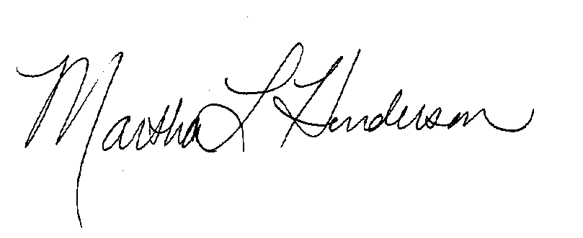
Martha L Henderson, Ph.D.
Director, Master of Environmental Studies
(360) 867-6841

mhenders@evergreen.edu

