January 24, 2025

Victoria (Cinder) Camerano Student ID: A00270570
PO Box 1504
Olympia, WA
98507

Dear Victoria,

I regret to inform you that the Graduate Program on the Environment Admissions Committee is unable to offer you admission to the Fall 2025 cohort of the Master of Environmental Studies degree. Should you be interested in applying again next year, you do not have to resubmit your letters of recommendation.

We appreciate your interest in the program and wish you the best of luck in your future ventures. If you have any questions, please contact me at leroyc@evergreen.edu.

Sincerely,
Carri LeRoy

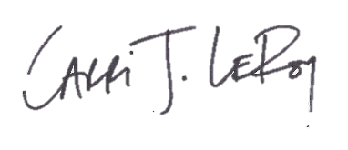
Carri LeRoy, Ph.D.
Director, Master of Environmental Studies Program
leroyc@evergreen.edu
360 867-5483

