June 6, 2024

To Whom It May Concern,

This letter confirms that Emma Stock has been admitted to the Fall 2024 Cohort in the Master of Environmental Studies program at The Evergreen State College and will matriculate officially on September 30, 2024. It is anticipated that Emma will graduate from the MES program at Evergreen June 12, 2026.

If you have any questions, please contact me at leroyc@evergreen.edu.

Sincerely,
Carri LeRoy

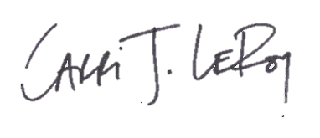
Carri LeRoy, Ph.D.
Director, Master of Environmental Studies Program
leroyc@evergreen.edu

