April 15, 2024

Kathy Wright Student ID: A00449729
PO Box 2573
Gig Harbor, WA
98335

Dear Kathy,

I regret to inform you that the Graduate Program on the Environment Admissions Committee is unable to offer you admission to the Fall 2024 cohort of the Master of Environmental Studies degree. Should you be interested in applying again next year, you do not have to resubmit your letters of recommendation.

If you would like to discuss ways to improve your application for the following year, I would be happy to meet and suggest strategies for improving your application. Please call or email me if you would like to meet.

We appreciate your interest in the program and wish you the best of luck in your future ventures. If you have any questions, please contact me at leroyc@evergreen.edu.

Sincerely,
Carri LeRoy

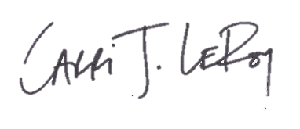
Carri LeRoy, Ph.D.
Director, Master of Environmental Studies Program
leroyc@evergreen.edu
360 867-5483

