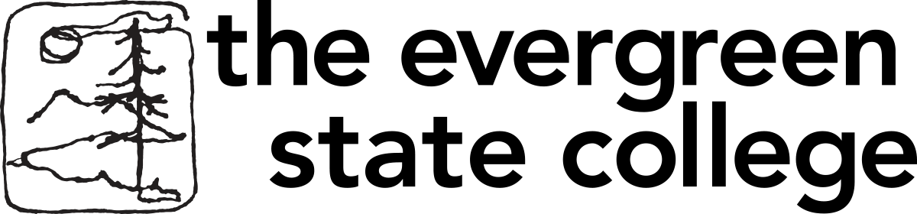

DEFERRAL - GRADUATE STUDENT DATA FORM
Complete this form and mail, fax, or email to:
The Evergreen State College
Graduate Admissions
Library 2002
Evergreen Parkway NW
Olympia WA 98505
graduateadmissions@evergreen.edu | Fax: 360-867-6794 | Phone: 360-867-6856

Legal Name: ______Roza Behroozi Nobar___________________________Defer to Spring20_22______
Check One: × MES € MIT € MPA
Mailing Address: ________95 Mohamadi Alley 45 Metri Kaj
South Niknezhad Azimiyeh,
Karaj, Iran (Islamic Republic Of)

Telephone: ( +98 )_____9120268164_ Alternate/Business Telephone:( +98)___________2632503548___

Email Address _____roza.behroozi@bihe.org_____________________________________

Baccalaureate Degree earned/expected from _________________________________ ___________
Name of Institution Date Conferred

Will you attend a college or university prior to entering the graduate program?

× No € Yes ___________________________________________
Name of College or Institution

List all courses you are taking or plan to take between now and entering the graduate program.

- _____________________________________________________________________

- _____________________________________________________________________

- _____________________________________________________________________

- _____________________________________________________________________

In signing this form, I acknowledge that failure to disclose and submit official transcripts from all schools, colleges, or universities attended and failure to disclose and submit complete and accurate information may result in dismissal from said institution. This includes submission of official transcripts upon completion of all academic work planned, or currently in progress. I understand that my deferral is incomplete without my signature below.

Signature of Student___________________Roza Behroozi Nobar______Date ________16 August 2021 __________

