WELCOME TO EVERGREEN!

This sheet provides you with **new student** information. Please read through it carefully.

**ACTIVATE your my.evergreen.edu account**!

The first step you must take to be an Evergreen student is to activate your Evergreen Online Student Services account (MyEvergreen) and Evergreen email. This is quick and easy to do, and **you must activate it now because all official communication from Evergreen regarding registration, financial aid and other important announcements will go to this email.**

1. **Go to my.evergreen.edu** and login as explained below.

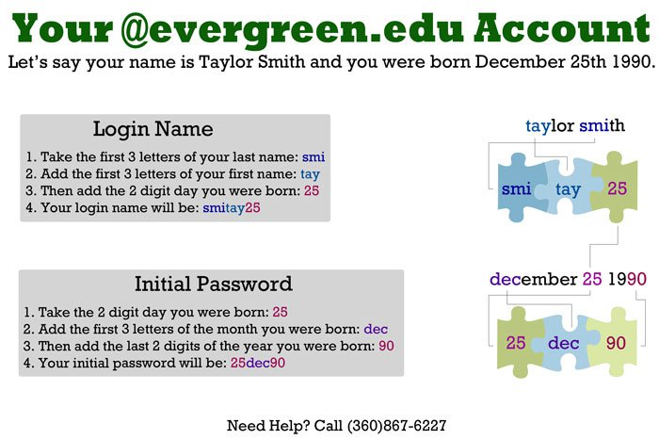

1. **Change your password:** The system will ask you to change your password. Make sure your password fits the minimum requirements as identified in this page and make sure it's something you can remember!
2. **Answer the secret question:** This is what you will need to have in case you forget your password.
3. **Select your email preference:** You can forward your Evergreen email to a third party provider (e.g., gmail.com). There are advantages to choosing this setting but there are also sometimes problems that can occur. (Note: A new Evergreen email is not issued to former student accounts. Therefore, users activating a former student account will not need to select an email preference but instead will go directly to the next step.)
4. **Accept the Copyright statement**

Once you have taken this last step, your @evergreen.edu email is created and you have an active student account that you will use to register for class, compose evaluations, pay tuition, check your financial aid, and more. You can access your email and student account at my.evergreen.edu or at the top of every evergreen.edu webpage.

*Need help? Call Academic Computing at 360-867-6227.*

**PAY your advanced tuition deposit!**

To accept your admission to MES, you must pay a $100 tuition deposit by June 22, 2018. This deposit is applied toward your Fall 2018 tuition at the time of enrollment. **It will be forfeited if you do not enroll.** You can pay online, in person, or by mail. *We do not accept payments by phone.* Cash is only accepted in person. Payment questions should go to the Cashier’s Office: 360-867-6445 or see evergreen.edu/business/cashier/paymentoptions.

**Pay Online**

Login to my.evergreen.edu, select **Student Financial Services**, and then follow these directions:

1.    Click on “Web Payment” under the **Students** section

2.    Click on “Make a payment” under “Current Balance Due”

3.    Choose “Tuition Deposit"

4.    Choose "Tuition Deposit for Graduate Studies”

5.    Choose the correct quarter (Fall 2018) and click the "add to basket" button

6.    Click on the "Pay Now" button

7.    Pay by credit/debit card (2.75% service fee) or e-check

**Pay By Mail**

* We accept checks or money orders (no cash) made payable to The Evergreen State College.  Please note your student ID# (found on the upper right of your admission letter) and that it is for your tuition deposit on the check/money order.
* Mail to:The Evergreen State College, Student Financial Services, 2700 Evergreen Parkway NW, Olympia WA  98505.

**Pay in Person**  
You can pay by cash, check/money order or debit card (no credit cards) in person at the Cashier’s Office, Library Building, Room 1118.