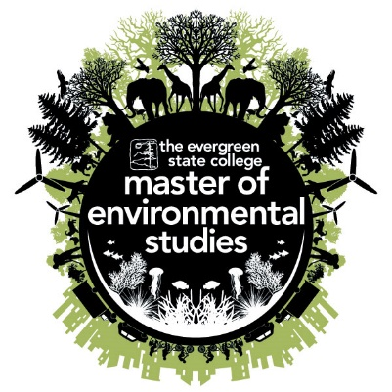

**MES Admitted Student Day Agenda**

**Thursday April 5th, 2018**

**10:30 AM** Check in (coffee, tea, & snacks provided)

**11:00 AM** Welcome and Ice Breaker

**11:30 AM** Program Overview

**12:00 PM** Faculty Introductions

**12:30 PM** Lunch

**1:30 PM** Alumni Panel

**2:15 PM** Break

**2:30 PM** Student Research Presentations

**3:00 PM** Campus Tour

**4:00 PM** Current Student Panel

