# MENTOR TEACHERS AS EVALUATORS

Mentors have asked us to provide a brief outline of expectations related to evaluating the candidate. A full description can be found in the *MiT Student Teaching Handbook, Sections 1 and 2.* We know you will want your candidate to be successful so we urge you to be honest about areas that need attention. Please talk to the college faculty right away if you need support in talking with the candidate.

* On a daily basis, review with the candidate what went well and point out one or two techniques, skills, or areas of knowledge to work on the next day.
* Carefully review the *MiT Student Teaching Rubric* in the *Student Teaching Handbook, Section 2.* In collaboration with your candidate, select a specific area each week to observe, notate on the rubric, and discuss.
* By the fifth week of the candidate’s time with you, be prepared to meet with the candidate and college faculty to discuss areas of strength and areas for improvement using the *Student Teaching Rubric* and other observations you’ve made as a basis for the discussion.
* By the last week of the candidate’s time with you, be prepared to meet with the candidate and college faculty to discuss the candidate’s areas of strength and areas for improvement using the *Student Teaching Rubric* and other observations you’ve made as a basis for the discussion.
* You will also be asked to write a summative evaluation of the candidate’s work based on the *Student Teaching Rubric*. This narrative evaluation and the marked *Student Teaching Rubric* are submitted to the college faculty at the final evaluation conference. The *Student Teaching Handbook, Section 1* provides information about the narrative evaluation.
* The Professional Educators Standards Board is now requiring that the mentor and college faculty provide a single numeric evaluation of the candidate’s achievement during student teaching. The scale is (1) Did not meet standard; (2) Approaching standard (some reservations); (3) Met standard; and, (4) Exemplary. The college faculty will discuss this requirement with you at your initial 3-way meeting.
* Though we do ask that you help the candidates plan opportunities to gather teaching and assessment information for the state-required *Teacher Performance Assessment (edTPA)*, you should *not* coach the candidate or provide feedback on the portfolio contents.
* The candidate may ask you for a letter of recommendation for her/his placement file. It’s up to you whether or not you wish to agree to this request.

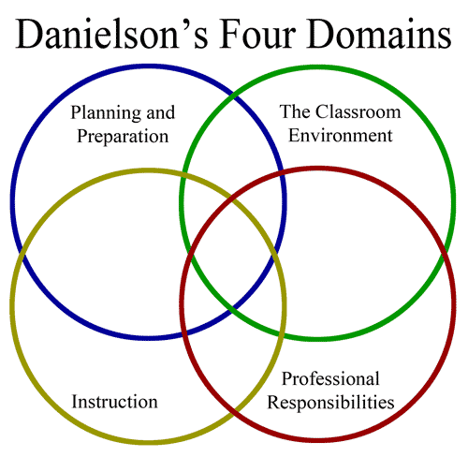

# MENTORS’ ROLES IN THE TEACHER PERFORMANCE ASSESSMENT (edTPA)

All candidates for certification in Washington are required to successfully complete the ed*TPA,* a portfolio-based assessment. Your candidate should provide you with a handbook outlining the expectations for your grade-level or content area. The requirements for the assessment and rubrics used to score the portfolio are in this handbook.

* Based on guidelines provided by Pearson, the company contracted by the state to develop and score the assessment, mentors *should not* be involved in the planning, assessment, teaching, data collection, or writing of the ed*TPA* portfolio. They *should not* provide feedback on the process or content.
* Mentors should support the candidate in:
  + Distributing and collecting a permission slip from parents, guardians, or youth over 18 that allows the candidate to video tape lessons and collect samples of student work. Candidates have a permission slip to use and are aware that students without written permission should be outside of camera range when lessons are taped.
  + Scheduling time to enact the various phases of the assessment as specified in the handbook provided by the candidate: pre-assessment of students, teaching, videotaping, and post-assessment of students.
* Mentors should expect the candidates to complete any data-analysis and written responses on their own time. Candidates should not skip days, arrive late, leave early, or use school time for these activities.

