MATH COLLABORATION: MiT AND LINCOLN OPTIONS ELEMENTARY SCHOOL

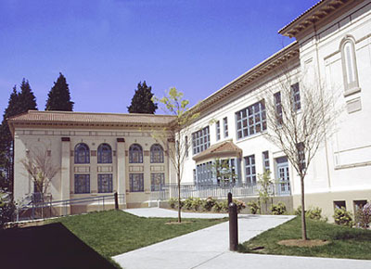

Sunshine Campbell and Anita Lenges, Evergreen MiT math education faculty, are participating in a 3-year collaboration with all teachers and the principal at Lincoln Options Elementary School, a local K-5 public alternative school in the Olympia School District. The collaboration between Evergreen and Lincoln is focused on developing students’ computational fluency using High Leverage Teaching Practices. The Lincoln teachers use part of their after-school staff meetings to focus on mathematics. During this time, Sunshine and Anita provide professional development dedicated to developing, clarifying or elaborating mathematical concepts, students’ development of ideas, and pedagogical moves that support students’ intellectual growth.

Sunshine and Anita lead three to four “Studio Days” per year. Studio Days include co-planning a mathematics lesson with two teachers (one primary and one intermediate) in a “fishbowl” with the other teachers. This planning takes place the day prior to the Studio Day. On the actual Studio Day, the lead teacher discusses the goals of the lessons and conducts a “dry run” with the teachers. This aims to prepare the lead teacher for the work with students through anticipating students’ potential engagement, questions, and conceptions. The teacher then leads the full class period with students while the primary or intermediate group of teachers, the principal, Sunshine and Anita observe students. Following the lesson, the group debriefs the learning experience, reflecting on the key pedagogical and mathematical concepts developed. Studio teachers rotate so that over a 2-year period of time, each teacher will have taught a studio class at least once.

The collaboration extends into further areas, including embedding MiT math methods classes at the school, arranging summer readings for teachers, presentations to the school boards and grant-writing.



