**CONNECTING WITH COMMUNITIES**

**Community Walks**

Preceding fall quarter field placements, knowledgeable community members guide our candidates on tours of neighborhoods and services surrounding schools in Clover Park, Tacoma, Olympia, and Shelton. The goal is to improve candidates’ understanding and appreciation of students’ out-of-school lives and communities’ funds of knowledge.

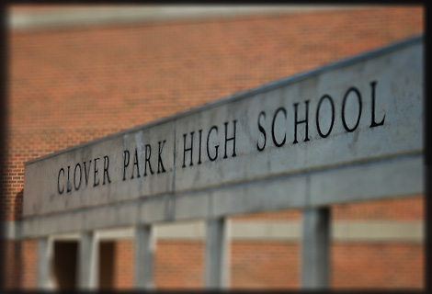 Clover Park

Olympia 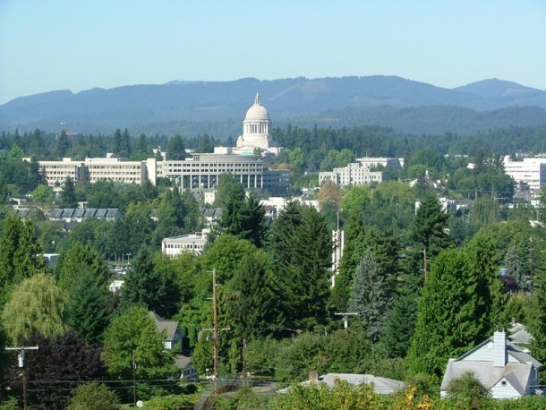

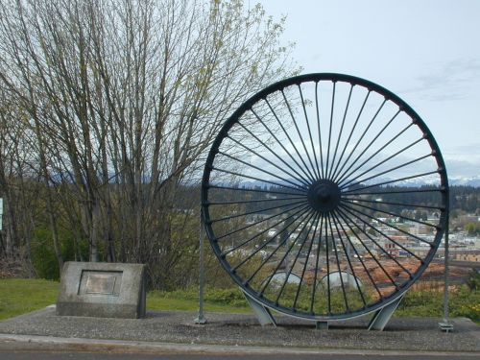 Shelton

**CONNECTING WITH COMMUNITIES**

**After-School Programs**

Some of our Tacoma-based MiT candidates will spend part of their field-experience time participating in an after-school program at First Creek Middle School, a program offered in conjunction with a 21st Century Grant awarded to the Puget Sound ESD. Other candidates will participate in after-school programs at Lincoln, Foss, and Mt. Tahoma High Schools as part of our collaboration with an Evergreen UpWard Bound grant.

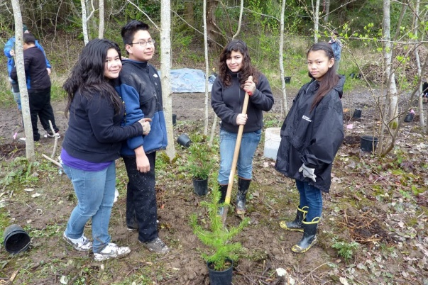

First Creek students in an after-school program

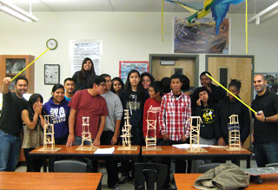

Lincoln High School students in an after-school

club for science, technology, engineering and

math