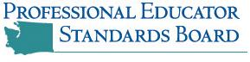
Certificate of Appreciation
Amber Zieske
for your service as a member of the 2013-2014
Professional Educator Advisory Board
The Evergreen State College
and Teacher Education Programs

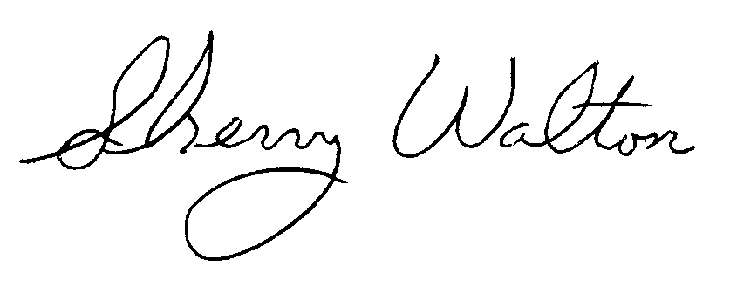

Sherry Walton, Director Jennifer Wallace, Executive Director
Evergreen Teacher Education Programs Professional Educator Standards Board

