

Program/PEAB Administrator Handbook

Guidelines for PEAB Operations

Revised April 2011

Professional Educator Standards Board
Old Capitol Building, Room 400
P.O. Box 47236
Olympia, WA 98504-7236

For more information about the contents
of this document, please contact:

Maggie Pazar, PESB
E-mail: maggie.pazar@k12.wa.us
Phone: 360.725.6326

This document is available online at http://program.pesb.wa.gov/peab

CONTENTS

- Program/PEAB Administrator 1
- Responsibilities 1
- Standards 1
- Procedures 2
- Program/PEAB Closure 2

- PEAB Membership 3
- College/University PEAB Membership 3
- Teacher PEABs 3
- Administrator PEABs 3
- School Counselor PEABs 3
- School Psychologist PEABs 4
- School Social Worker PEABs 4
- PEAB Membership Appointments 4
- Educational Service District Administrator Professional Certificate PEAB Membership 5
- New Member Requests 5
- Can Retired Educators Serve on a PEAB? 6
- Member Attendance 6

- Guidelines for PEAB Grant Expenditures 7
- Purpose 7
- Procedures 7
- Allowable Expenses 7
- Non-allowable Expenses 7

- Instructions for Reimbursement of Pay of Substitutes
for Teachers Serving on PEABs 9
- Administrative Policy 9
- Release Authorization 9
- Substitute Reimbursement Paperwork Processing Procedures
  - Program/PEAB Administrator or Designee Responsibilities
- Prior to Meeting: Forms SPI 605 & 720 / Submission Deadline 9
- At Meeting: Form SPI 720 / Sign-in Sheet 9
- After Meeting: Sign-in Sheet / Form SPI 720 10
- Responsibility of Teacher Requiring Substitute
- At Meeting: Form SPI 720 10
- After Meeting: Form SPI 720 10
- School District Responsibilities
- Post Meeting: Form SPI 720 / Submission Deadline 10

- OFM Travel Regulations and Procedures 11

- Annual Report Tips 13

- Appendices 15
- Per Diem Rates—October 1, 2010, with January 2011 mileage rates
- Sign-in Sheet
- Sample Form SPI 605, rev. 2/09—Authorization for Reimbursement of Pay of Substitutes with instructions
- Sample Form SPI 720, rev. 4/10—Substitute Teacher Reimbursement Invoice Voucher with instructions

Program/PEAB Administrator

Responsibilities
Under the approval standard—Required Professional Education Advisory Board (PEAB) WAC 181-78A-205, institutions and organizations seeking approval by the Professional Educator Standards Board (PESB) as an approved preparation program, and in order to maintain such approval status, shall establish a PEAB.
Each institution or organization operating an approved preparation program shall require the dean, director, or other designee of the administrative unit to be responsible for PEABs and the operation of the preparation programs (WAC 181-78A-136). The Program/PEAB Administrator is the college/university person who is administratively responsible for directing and managing a preparation program on a day-to-day basis including the PEAB activities. The Program/PEAB Administrator has responsibility for the following Program/PEAB approval standards (WAC 181-78A-250):

Standards
Building on the mission to prepare educators who demonstrate a positive impact on student learning, the following evidence shall be evaluated to determine whether each preparation program is in compliance with the program approval standards of WAC 181-78A-220(1):
- The PEAB has been established in accordance with WAC 181-78A-209.
- The educational service district professional education advisory board for a professional certification program has been established in accordance with WAC 181-78A-520.
- The PEAB has adopted operating procedures and has met at least three times a year.
- The professional education advisory board has reviewed all program approval standards at least once every five years.
- The professional education advisory board annually has reviewed and analyzed data for the purposes of determining whether candidates have a positive impact on student learning and providing the institution with recommendations for programmatic change. This data may include, but not be limited to: Student surveys, follow-up studies, employment placement records, student performance portfolios, course evaluations, and summaries of performance on the pedagogy assessment for teacher candidates.
- The PEAB has made recommendations when appropriate for program changes to the institution which must in turn consider and respond to the recommendations in writing in a timely fashion.
- The PEAB annually has seen, reviewed and approved an executive summary of the activities of the PEAB. The college or university has submitted the approved executive summary to the PESB.
- The PEAB for administrator preparation programs participation in the candidate selection process for principal programs.
PLEASE NOTE: While your institution may select a PEAB chair that is not an institutional employee, the Program/PEAB administrator must be an employee of the college/university.

Procedures
Program/PEAB Administrators will ensure that the following procedures take place:
- Beginning of the Year. Submit PEAB membership form to PESB by July 31, 2011. The membership form is located at: http://goo.gl/D8e5Y
- Throughout the year. Precertification funds received are expended within guidelines established by WAC 181-79A-131, Guidelines for PEAB Grant Expenditures (see Part III) and Washington State Office of Financial Management (OFM) rules. Record keeping is performed (see Part III).
- Each PEAB Meeting. Prepare documentation for substitute reimbursements. See instructions in Parts IV and V and forms and sample forms in the Appendices (A-D). Expenditures of precertification funds received adhere to state per diem regulations (see Part III).
- End of the Year. Prepare and submit annual PEAB reports per WAC 181-78A-250(7) and WAC 181-78A-520(2)(b)(v). See instructions in Part VI. Expenditure reimbursement invoices are properly prepared and submitted to the PEAB’s fiscal agent.

- Program/PEAB Closure
If a Program/PEAB closes, unexpended funds remain with or are returned to Puget Sound ESD, the fiscal agent for the PESB.

PEAB Membership

College/University PEAB Membership

WAC 181-78A-209 Professional education advisory boards—Membership. The professional education advisory boards shall at a minimum consist of the following:

(1) TEACHER.

(a) One-half or more of the voting members shall be classroom teachers. All, but one, will be appointed by the president of the Washington Education Association. The remaining teacher shall be employed in a state-approved private school and appointed by the Washington Federation of Independent Schools.

(b) At least one principal appointed by the president of the Association of Washington School Principals.

(c) At least one school administrator appointed by the Washington Association of School Administrators.

(d) At least one educational staff associate (school counselor, school psychologist, school social worker, school nurse, school occupational therapist, school physical therapist, or school speech language pathologist or audiologist) appointed by the president of the individual's professional association.

(e) At least one institution or organization representative who may serve in a voting or nonvoting role.

(f) At programs where career and technical education programs are offered, one career and technical education director or career and technical education teacher, with expertise in one of the approved career and technical education programs at the institution or organization, appointed by the Washington Association of Vocational Administrators in cooperation with the institution or organization.

(2) ADMINISTRATOR.

(a) One-half or more of the voting members shall be administrators. One-half of these administrators shall be appointed by the president of the Washington Association of School Administrators. The remaining administrators shall be appointed by the president of the Association of Washington School Principals except one who shall be employed in an approved private school and appointed by the Washington Federation of Independent Schools.

(b) At least one or more classroom teachers appointed by the president of the Washington Education Association.

(c) At least one educational staff associate (school counselor, school psychologist, school social worker, school nurse, school occupational therapist, school physical therapist, or school speech language pathologist or audiologist) appointed by the president of the individual's professional association.

(d) At least one institution or organization representative who may serve in a voting or nonvoting role.

(3) SCHOOL COUNSELOR.

(a) At least one-half of the voting members shall be school counselors appointed by the president of the Washington School Counselors Association.

(b) At least one teacher appointed by the president of the Washington Education Association.

(c) At least one principal appointed by the Association of Washington School Principals.

(d) At least one administrator appointed by the Washington Association of School Administrators.

(e) At least one institution or organization representative who may serve in a voting or nonvoting role.

(4) SCHOOL PSYCHOLOGIST.

(a) At least one-half of the voting members shall be school psychologists appointed by the president of the Washington State Association of School Psychologists.

(b) At least one teacher appointed by the president of the Washington Education Association.

(c) At least one principal appointed by the Association of Washington School Principals.

(d) At least one administrator appointed by the Washington Association of School Administrators.

(e) At least one institution or organization representative who may serve in a voting or nonvoting role.

(5) SCHOOL SOCIAL WORKER.

(a) At least one-half of the voting members shall be school social workers appointed by the president of the Washington Association of School Social Workers.

(b) At least one teacher appointed by the president of the Washington Education Association.

(c) At least one principal appointed by the Association of Washington School Principals.

(d) At least one administrator appointed by the Washington Association of School Administrators.

(e) At least one institution or organization representative who may serve in a voting or nonvoting role.

(6) MEMBERSHIP APPOINTMENTS. Applicable to all professional association appointments, if the professional association does not respond to the program's request for an appointment of a representative within sixty days of the receipt of the request, a program may appoint the representative of its choice in the role for which an appointment is being sought. If the program makes an appointment, it must notify the appropriate professional association within one week that the appointment has been made. If an association is unable to appoint a representative due to the geographic restriction of possible candidates, the PEAB will appoint an alternate to represent that association with their consent.

[Statutory Authority: RCW 28A.410.210. 11-01-047, § 181-78A-209, filed 12/7/10, effective 1/7/11; 09-20-110, § 181-78A-209, filed 10/7/09, effective 11/7/09; 07-04-004, § 181-78A-209, filed 1/24/07, effective 2/24/07. 06-02-051, recodified as § 181-78A-209, filed 12/29/05, effective 1/1/06. Statutory Authority: RCW 28A.410.010 and 28A.305.130 (1) through (4). 02-04-018, § 180-78A-209, filed 1/24/02, effective 2/24/02. Statutory Authority: RCW 28A.305.130 (1) and (2). 01-03-151, § 180-78A-209, filed 1/24/01, effective 2/24/01; 00-09-046, § 180-78A-209, filed 4/14/00, effective 5/15/00. Statutory Authority: RCW 28A.305.130 (1) and (2), 28A.410.010 and 28A.150.220(4). 99-01-174, § 180-78A-209, filed 12/23/98, effective 1/23/99.]

Educational Service District Administrator Professional Certificate PEAB Membership

WAC 181-78A-520 (2)(b)(i) Professional education advisory board—Educational Service District Administrator Professional Certificate—Membership.
(i) Membership. The professional education advisory board shall consist of the following:
(A) One college or university representative, from the educational service district region, appointed by the Washington council of educational administration programs;
(B) One superintendent appointed by the Washington association of school administrators from the educational service district region;
(C) One district human resource representative;
(D) One teacher with national board certification, from the educational service district region, appointed by the Washington education association;
(E) One educational service district representative with responsibility for inservice/professional development; and
(F) Two principals, from the educational service district region, appointed by the Washington association of school principals.

[Statutory Authority: RCW 28A.410.210. 09-16-053, § 181-78A-520, filed 7/29/09, effective 8/29/09; 07-04-004, § 181-78A-520, filed 1/24/07, effective 2/24/07; 06-14-010, § 181-78A-520, filed 6/22/06, effective 7/23/06. 06-02-051, recodified as § 181-78A-520, filed 12/29/05, effective 1/1/06. Statutory Authority: RCW 28A.410.010 and 28A.305.130 (1) and (2). 00-03-049, § 180-78A-520, filed 1/14/00, effective 2/14/00. Statutory Authority: RCW 28A.305.130 (1) and (2), 28A.410.010 and 28A.150.220(4). 99-01-174, § 180-78A-520, filed 12/23/98, effective 1/23/99.]

New Member Requests

Consult the PESB website to secure the name and contact information for the appropriate professional association contact (contact list available online at http://program.pesb.wa.gov/peab). You must contact that individual as soon as possible, via both regular mail* and email. The association contact has 60 days from the time of receipt of your request to provide you with their nominee. In your request to the designated association contact, please specify:
  - The specific role requested;
  - When applicable, any additional criteria related to endorsement areas, grade level band, geographic representation, or need for increased representation from underrepresented populations;
  - Upcoming PEAB meeting dates; and
  - A list of districts with whom your program has field placement agreements.

*Note: the various professional associations use varying procedures for appointing PEAB members. The Washington Education Association has asked that PEAB administrators be conscious of the following guidelines when requesting teacher appointments for any PEAB:

The Washington Education Association annually appoints more than 300 educators to serve on PEABs. In 2009, it implemented a new web-based recruitment tool to enhance the efficiency and timeliness of the appointment process. This new system allows WEA to secure the support of local association presidents and to gather key information about appointees, including their contact information, institutions attended, reasons for wanting to serve on a PEAB, etc.

With this new process, WEA no longer takes nominations from colleges and universities about recommended appointees, but will continue to do their best to find appointees who meet requested demographics (e.g., specific geographic region, school district, content area or level). However, a specific fit may not always be possible. Given tighter budgets, they will also seek to find appointees who live within a reasonable driving distance from the college/university.

Please send all requests for appointments directly to Jim Meadows by email at: jmeadows@washingtonea.org

It is no longer necessary to submit a request in writing/snail mail to the WEA President.

Can Retired Educators Serve on a PEAB?

The intent of the rules is that PEAB members should be current practitioners. Retired educators can be members of PEABs—but they cannot count toward the official required representation.

Member Attendance

What to do if PEAB meeting attendance is low:
- If attendance, in general, is low, consider:
- Conducting meetings via K-20
- Scheduling late afternoon and/or evening meetings
- Review by-laws to be sure attendance procedures are followed.
- If an individual’s attendance is low, contact the individual. If the problem persists, contact the appropriate appointing association.
- If an individual’s attendance is low, contact the individual. If the problem persists, contact the appropriate appointing association.
- Minimum attendance is a program decision. By-laws should indicate the necessary quorum for reviewing portfolios and/or conducting general business.

Guidelines for PEAB Grant Expenditures

Purpose
The primary utilization of funds designated for precertification activities shall be to support collaborative efforts essential to program development, program evaluation, and assessment of candidates’ entry and exit competency; and shall not supplant funds already available to any participating agency. WAC 181-79A-131 (2)(a)(b).

Procedures
The PEAB has the responsibility of performing the following duties:
- Keeping expenditures within guidelines established by WAC 181-79A-131, Guidelines for PEAB Grant Expenditures (Part III), and Washington State Office of Financial Management (OFM) rules.
- Record keeping (i.e., revenue and related expenditures receipts). Follow directions provided to you by your fiscal agent.
- Maintain books, records, documents and other evidence which sufficiently and properly reflect funds expended in the performance of precertification activities. These records shall be subject to inspection, review or audit by personnel of the college/university PEAB, PEAB fiscal agents, PSESD, Director, Superintendent, and the Office of the State Auditor.
- Retain all books, records, documents, and other relevant material for six (6) years after fiscal year records are closed; and the Office of the State Auditor and any persons duly authorized by the parties shall have full access and the right to examine any of these materials during this period.

Allowable Expenses
The PEAB has the responsibility to participate in and cooperate with the college/university on decisions related to the development, implementation, and revision of each professional preparation program. WAC 181-78A-220 (1).
To serve in this role, PEABs meet three times per calendar year WAC 181-78A-250 (3). Grant award funds may be used for costs related to training such as the payment of professional contractual services, per diem, travel costs, materials, printing, or released time (see Appendix A Per Diem Rates and OFM rules) to support these meetings, WAC 181-79A-131(5). Funding is provided for three meetings.

Non-allowable Expenses
  - Funds set aside for precertification shall not supplant funds already available to any participating agency. WAC 181-79A-131 (2)(a)(b).
  - College/university tuition and fees are non-allowable costs. WAC 181-79A-131(5).
  - Gratuity recognition and payment to PEAB members are not allowable expenses based on OFM rules and legal counsel.
  - Stipends, honorariums, contractual services, etc. cannot be paid to PEAB members for participation in meetings.
  - Members are not eligible for payment for performing routine PEAB activities (e.g., preparing annual reports and reviewing/screening candidates for program admission).
  - Requests to reimburse costs associated with substitutes for public and private school teachers should be processed via SPI FORMS 605 and 720 (see instructions in Part IV). Your PEAB grant award funds should not be used to pay for substitutes. Private school substitutes can be reimbursed, per the Attorney General.

Expenditures of precertification funds are subject to audit. Therefore, expenditure receipts and other records that provide evidence that expenditures are within the parameter of precertification funds must be available upon audit request, and for PESB site visits.

Instructions for Reimbursement of Pay of Substitutes for Teachers Serving on PEABs

Administrative Policy
Provision is made in WAC 181-78A-215 for reimbursement of pay of substitutes to school districts for PEAB members who are certificated or classified individuals employed by a public school district or private school within Washington State.

Release Authorization
School districts are authorized to release certificated personnel for services on PEABs without prior letters of authorization from PESB.

Substitute Reimbursement Paperwork Processing Procedures:

Below are the responsibilities related to substitute reimbursement paperwork processing:

Program/PEAB Administrator or Designee Responsibilities

Prior to Each PEAB Meeting: Forms SPI 605 & 720 / Submission Deadline

Submit—30 days prior to each PEAB meeting—one authorization for substitute reimbursement (FORM SPI 605, rev 2/09) to Christine Mager, PESB, P.O. Box 47236, Olympia, WA 98504-7236, Phone: (360) 725-4478, FAX (360) 586-4548, christine.mager@k12.wa.us (see Appendix C-1 for sample completed form and Appendix C-2 for directions on completing and submitting the form). Appendix D-1 and D-2 can be printed back to back for handy reference. Submit only current forms. Old forms will be returned for updating. No signature is required.

If more than one PEAB is meeting on the same day, do not submit one meeting form unless the groups are meeting jointly.
After this form is submitted . . .

If a meeting is cancelled, please notify Christine.

If a meeting is rescheduled, please notify Christine and send an updated Form 605.

If there is a change in the number of substitutes, please contact Christine to determine is she needs a revised form.
NOTE: All FORM SPI 605 forms must be submitted prior to June 30 of the fiscal year in which the meeting occurred. Failure to meet this deadline may obligate the institution to pay the reimbursement.
- Complete a portion of Substitute Teacher Reimbursement Invoice Voucher (FORM SPI 720, rev. 4/10), to be given to teacher at the PEAB meeting (see Appendix D-1 for sample completed form and Appendix D-2 for directions on completing and submitting the form) Appendix D-1 and D-2 can be printed back to back for handy reference. Current forms must be used. Old forms will be returned for reprocessing.
- Refer school districts requesting a release letter to WAC 181-78A-215.

At Each PEAB Meeting: Form SPI 720 / Sign-in Sheet
- Provide prepared substitute teacher reimbursement invoice voucher (FORM SPI 720, rev. 4/10, see above bulleted instructions under “Prior to the Meeting”) to the teacher who required a substitute. The teacher submits the form to the school district business office (see Appendix D-1 for sample completed form and Appendix D-2 for directions on completing and submitting the form).
- Obtain signature of attendees, using sign-in sheet provided in this handbook (Appendix C). Attendees should indicate on the form whether a substitute teacher was employed.
- After Each PEAB Meeting: Sign-in Sheet / Form SPI 720
- Send original sign-in sheet for each PEAB meeting to Christine Mager, PESB, P.O. Box 47236, Olympia, WA 98504-7236, Phone: (360) 725-4478, FAX (360) 586-4548, christine.mager@k12.wa.us.
- If prepared Substitute Teacher Reimbursement Invoice Voucher (FORM SPI 720, rev. 4/10, see above bulleted instructions under “Prior to the Meeting”) was not given to teacher at the meeting, mail the prepared form to the teacher’s school district.

Responsibility of Teacher Requiring Substitute:

At Each PEAB Meeting: Form SPI 720
- Receive current substitute teacher reimbursement invoice voucher FORM SPI 720 (rev. 4/10) prepared by the Program/PEAB Administrator or designee. If current form not received, contact Program/PEAB Administrator or designee.
- After Each PEAB Meeting: Form SPI 720
- Submit current substitute teacher reimbursement invoice voucher FORM SPI 720 (rev. 4/10) provided by the Program/PEAB Administrator to school district business office in a timely manner. Current forms must be submitted to the school district. If current form not received, contact Program/PEAB Administrator or designee.

School District Responsibilities:
- After Each PEAB Meeting: Form SPI 720 /Submission Deadline
- Receive prepared current substitute teacher reimbursement invoice voucher FORM SPI 720 (rev. 4/10) from teacher or Program/PEAB Administrator or designee.
- Ensure form is current. If form is not current, school district contacts Program/PEAB Administrator or designee for current form.
- Appropriate business office representative fill in the rate and amount and sign the form.
- Attach complete, signed FORM SPI 720 (rev. 4/10) if a school district invoice is used.
- Mail completed FORM SPI 720 (rev. 4/10) to the Fiscal Office, Superintendent of Public Instruction, PO Box 47200, Olympia WA 98504-7200, no later than 30 days after the meeting.
- Submit all forms by June 30, the end of the fiscal year. Forms received after the close of the fiscal year cannot be processed. Incomplete forms will be returned to the school district unprocessed.

OFM Travel Regulations and Procedures

RCW 43.03.050 Subsistence, lodging and refreshment, and per diem allowance for officials, employees, and members of boards, commissions, or committees.
(1) The director of financial management shall prescribe reasonable allowances to cover reasonable and necessary subsistence and lodging expenses for elective and appointive officials and state employees while engaged on official business away from their designated posts of duty. The director of financial management may prescribe and regulate the allowances provided in lieu of subsistence and lodging expenses and may prescribe the conditions under which reimbursement for subsistence and lodging may be allowed. The schedule of allowances adopted by the office of financial management may include special allowances for foreign travel and other travel involving higher than usual costs for subsistence and lodging. The allowances established by the director shall not exceed the rates set by the federal government for federal employees. However, during the 2003-05 fiscal biennium, the allowances for any county that is part of a metropolitan statistical area, the largest city of which is in another state, shall equal the allowances prescribed for that larger city.
(2) Those persons appointed to serve without compensation on any state board, commission, or committee, if entitled to payment of travel expenses, shall be paid pursuant to special per diem rates prescribed in accordance with subsection (1) of this section by the office of financial management.
(3) The director of financial management may prescribe reasonable allowances to cover reasonable expenses for meals, coffee, and light refreshment served to elective and appointive officials and state employees regardless of travel status at a meeting where: (a) The purpose of the meeting is to conduct official state business or to provide formal training to state employees or state officials; (b) the meals, coffee, or light refreshment are an integral part of the meeting or training session; (c) the meeting or training session takes place away from the employee's or official's regular workplace; and (d) the agency head or authorized designee approves payments in advance for the meals, coffee, or light refreshment. In order to prevent abuse, the director may regulate such allowances and prescribe additional conditions for claiming the allowances.
(4) Upon approval of the agency head or authorized designee, an agency may serve coffee or light refreshments at a meeting where: (a) The purpose of the meeting is to conduct state business or to provide formal training that benefits the state; and (b) the coffee or light refreshment is an integral part of the meeting or training session. The director of financial management shall adopt requirements necessary to prohibit abuse of the authority authorized in this subsection.
(5) The schedule of allowances prescribed by the director under the terms of this section and any subsequent increases in any maximum allowance or special allowances for areas of higher than usual costs shall be reported to the ways and means committees of the house of representatives and the senate at each regular session of the legislature.
(6) Beginning July 1, 2010, through June 30, 2011, no person designated as a member of a class one through class three or class five board, commission, council, committee, or similar group may receive an allowance for subsistence, lodging, or travel expenses if the allowance cost is funded by the state general fund. Exceptions may be granted under section 605, chapter 3, Laws of 2010.

[2010 1st sp.s. c 7 § 141; 2003 1st sp.s. c 25 § 915; 1990 c 30 § 1; 1983 1st ex.s. c 29 § 1; 1979 c 151 § 83; 1977 ex.s. c 312 § 1; 1975-'76 2nd ex.s. c 34 § 94; 1970 ex.s. c 34 § 1; 1965 ex.s. c 77 § 1; 1965 c 8 § 43.03.050. Prior: 1961 c 220 § 1; 1959 c 194 § 1; 1953 c 259 § 1; 1949 c 17 § 1; 1943 c 86 § 1; Rem. Supp. 1949 § 10981-1.]

Notes:
Effective date -- 2010 1st sp.s. c 26; 2010 1st sp.s. c 7: See note following RCW 43.03.027.
Severability -- Effective date -- 2003 1st sp.s. c 25: See notes following RCW 19.28.351.
Effective date -- Construction -- 1977 ex.s. c 312: "This act is necessary for the immediate preservation of the public peace, health, and safety, the support of the state government and its existing public institutions, and shall take effect immediately except that any new schedule of allowances under either RCW 43.03.050 and 43.03.060 as now or hereafter amended shall not be effective until July 1, 1977 or later." [1977 ex.s. c 312 § 5.]
Effective date -- Severability -- 1975-'76 2nd ex.s. c 34: See notes following RCW 2.08.115.

Note: Please use the per diem rates for the geographic area where the PEAB meeting is held. See appendices for Washington State per diem map.

VI. Annual Report Tips

The PEAB reporting process is in transition, and we no longer use the format that was in place through 2008-09. Instead, PEABs are asked to report the following:

- By July 31 of each year, we ask that you provide us with:

The number of voting members for the upcoming year (2011-12)
  - The fund balance as of June 30 of the current year (2011)
  - The name of your fiscal agent for the upcoming year (2011-12)

- By November 1 of each year, we ask you to submit information on the substantive work of the PEAB. This information may vary somewhat from year to year, but will typically include PEAB recommendations and program responses; PEAB and program responses to any unmets and recommendations on recent site visits; and an indication of data reviewed by the PEAB in the past year.

E-mail reminders will be sent to PEAB administrators well in advance of the due date for each report.

VII. Appendices

Per Diem Rates as of October 1, 2010, with January 2011 mileage rate change A

Sign in Sheet B

Form SPI 605, rev. 2/09—Authorization for Reimbursement of Pay of Substitutes C

Form SPI 720, rev. 4/10—Substitute Teacher Reimbursement Invoice Voucher D

State Per Diem Maps are accessible at the Washington State Office of Financial Management’s web site (check for updates, especially in January, July, and October):

Institution Program/PEAB

Date

Name (printed) Signature District Sub Teacher Required?
□ YES □ NO
□ YES □ NO
□ YES □ NO
□ YES □ NO
□ YES □ NO
□ YES □ NO
□ YES □ NO
□ YES □ NO
□ YES □ NO
□ YES □ NO
□ YES □ NO
□ YES □ NO

Sample Form SPI 605 (rev. 2/09)—Authorization for Reimbursement of Pay of Substitutes
Form SPI 605 (Authorization for Reimbursement of Pay of Substitutes) is available in a WORD format that can be filled out and printed. You can download a copy at http://program.pesb.wa.gov/peab.
A sample completed form is below. Directions on filling out the form are on the following page (Appendix C-2). (Appendix C-2 and this page can be printed back to back for handy reference).
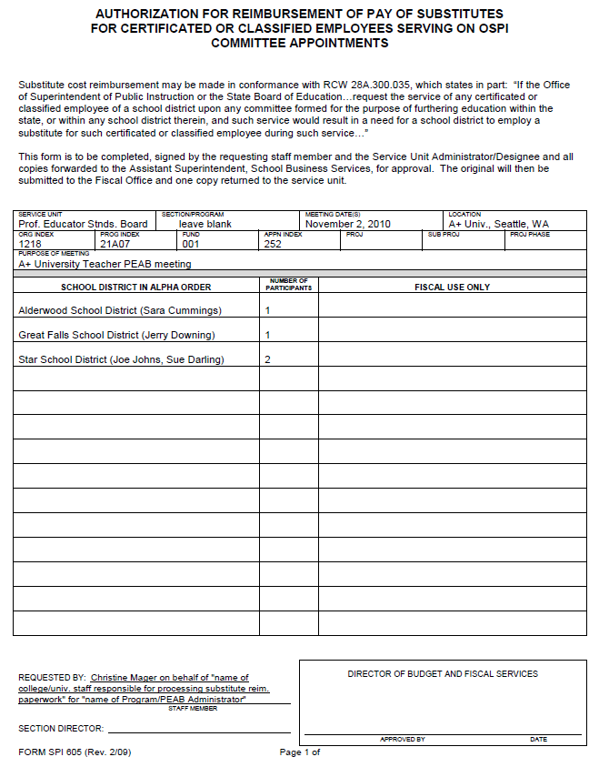

PLEASE NOTE: Current FORM SPI 605s must be used. The current form is FORM SPI 605 (rev. 2/09). Old forms will be returned for updating. (Appendix C-1 and this page can be printed back to back for handy reference).

Submission Deadline: All FORMs SPI 605 must be submitted prior to June 30 of the fiscal year in which the meeting occurred. Failure to meet this deadline may obligate the institution to pay the reimbursement.

Forms must be submitted 30 days prior to the date of the meeting. No signature is required.

Please submit form via email, fax, or mail to: Christine Mager, Office Assistant, Professional Educator Standards Board, P.O. Box 47236, Olympia, WA 98504-7236, Phone: (360) 725-4478, FAX (360) 586-4548, christine.mager@k12.wa.us

If a meeting is cancelled, please notify Christine.

If a meeting is rescheduled, please notify Christine and send an updated Form 605.

If there is a change in the number of substitutes, please contact Christine to determine is she needs a revised form.

If more than one PEAB is meeting on the same day, do not submit one meeting form unless the groups are meeting jointly.
Section on  Form SPI 605 | Section Specific Information  Fill in section as indicated, type or print legibly
Service Unit | Prof. Educator Stnds Board
Section/Program | Leave blank
Meeting Date | Date of the meeting (month, date(s), and year)  Submit one form per meeting.
Location | Facility and city where the meeting will be held
Org Index | 4000
Prog Index | 21A07
Fund | 001
Appn Index | 252
Purpose of Meeting | Name of the PEAB. Example: UW-Seattle Teacher PEAB  (include college/university name or abbreviation of name and type of PEAB.)
School District | Name of school district(s) or private school(s) where teacher(s) is employed. Include, in parenthises, the name of the teacher(s) after the name of the school district. For example: Cheney School District (John Doe, Jane Doe)  List school districts in alphabetical order. List private schools in alphabetical order after school districts.
Number of Participants | The number of teachers at each school district for whom substitute teachers are needed.
Fiscal use only | For OSPI Fiscal use only.
Requested by | Christine Mager on behalf of “name of person responsible for processing substitute reimbursement paperwork” for “name of program/PEAB administrator”  For example: Maggie Pazar on behalf of Terry Jones for Sandy Knutsen
Section Director | Leave blank—PESB office use
Director of Budget and Fiscal Services | Leave blank—OSPI use

Sample Form SPI 720 (rev. 4/10)—Substitute Teacher Reimbursement Invoice Voucher

Form SPI 720 (Substitute Teacher Reimbursement Invoice Voucher) is available in a WORD format that can be filled out and printed. You can download a copy at http://program.pesb.wa.gov/peab.

A sample completed form is below. Directions on filling out the form are on the following page (Appendix D-2). (Appendix D-2 and this page can be printed back to back for handy reference).
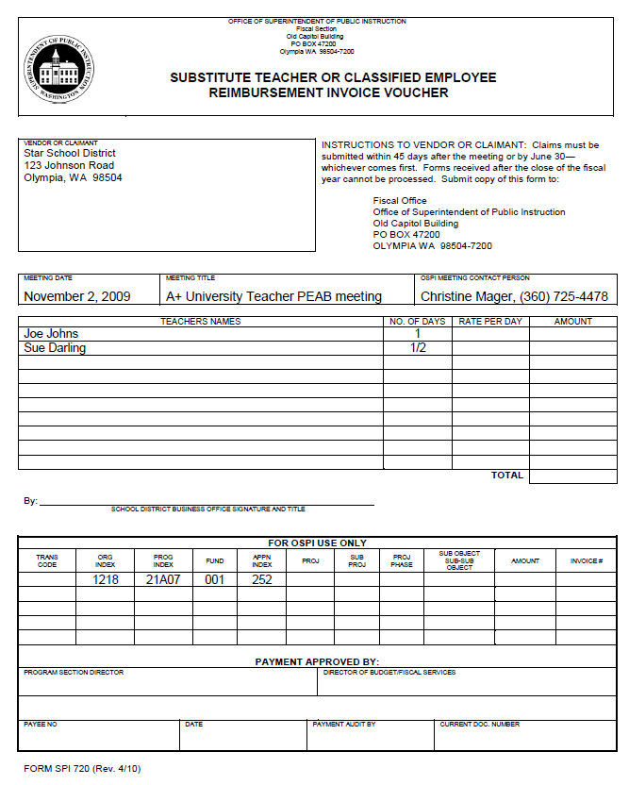
PLEASE NOTE: Current FORM SPI 720s must be used. The current form is FORM SPI 720 (rev. 4/10). Old forms will be returned for reprocessing. (Appendix D-1 and this page can be printed back to back for handy reference).
Prior to Each PEAB Meeting:
Program/PEAB Administrator or designee completes portion of Substitute Teacher Reimbursement Invoice Voucher (FORM SPI 720, rev. 4/10). The table below states the information to include on FORM 720 prior to the meeting:
Section on  Form SPI 720 | Specific Section Information  Fill in section as indicated, type or print legibly
Vendor or Claimant | School district name and address
Meeting Date | Date(s) of the meeting
Meeting Title | Name of the PEAB, example: UW-Seattle Teacher PEAB Meeting  (include college or university name or abbreviation of name and type of PEAB)
OSPI Meeting Contact | Christine Mager, (360) 725-4478
Teachers Name | Name(s) of the PEAB member (teacher) and district in which employed.
Number of Days | Number of days that the teacher’s school district employed a substitute while he/she was attending your PEAB meeting.
Director of Budget and Fiscal Services | Leave blank—OSPI use
Org Index | 4000
Prog Index | 21A07
Fund | 001
Appn Index | 252
At Each PEAB Meeting:
Program/PEAB Administrator or designee provides prepared FORM SPI 720( rev. 4/10) to teacher requiring substitute reimbursement.
After Each PEAB Meeting:
- If prepared FORM SPI 720, rev. 4/10, was not given to teacher at the meeting, Program PEAB Administrator or designee mails form to the teacher’s school district.
- Teacher provides current prepared FORM SPI 720 (rev. 4/10) provided by the Program/PEAB Administrator to school district business office in a timely manner.
- School District receives prepared current substitute teacher reimbursement invoice voucher FORM SPI 720 (rev. 4/10) from teacher or Program/PEAB Administrator or designee.
- School ensures form is current. If form is not current, school district contacts Program/PEAB Administrator or designee for current form.
- Appropriate business office representative verifies information on form, fills in the rate and amounts and signs the form:
Section on  Form SPI 720 | Specific Section Information  Fill in section as indicated, type or print legibly
Vendor or Claimant | Verify school district information is correct.
Number of Days | Verify the number of days is correct
Rate per Day | Add the rate of pay per day to be reimbursed.
Amount | Total dollar amount (rate times the number of days).
Ensure appropriate school district business office signature and title are on the line indicated
- School District attaches the completed FORM SPI 720 if a school district invoice is used.
- School District mails completed FORM SPI 720 to the Fiscal Office, Superintendent of Public Instruction, PO Box 47200, Olympia WA 98504-7200, no later than 30 days after the meeting.
- School District submits all forms by June 30, the end of the fiscal year. Forms received after the close of the fiscal year cannot be processed. Incomplete forms will be returned to the school district unprocessed.

