Loren’s Top Ten List: How to say Goodbye to Maggie!!!

1. I wish you well. Be Happy.

2 Take care. Love you.

3. Silent hugs and/or kisses

4. It has been wonderful. I'll laugh about our times together forever.

5. You are the BEST (wave with a smile)

6. Keep up the good work. You're doing a great job...See ya !

7. Thank you (for the good times) Au revoir.

8 .Ta ta! Cheerio! Pip Pip!

9. My dad's favorite: Keep your head down!

10. My brother’s favorite (to me anyway): As he carries my suitcase the complete length of the driveway and opens the car door for me, with me protesting,” I can manage, you don't have to come all this way to the car....” " I have to make sure you are gone. Off you go!"

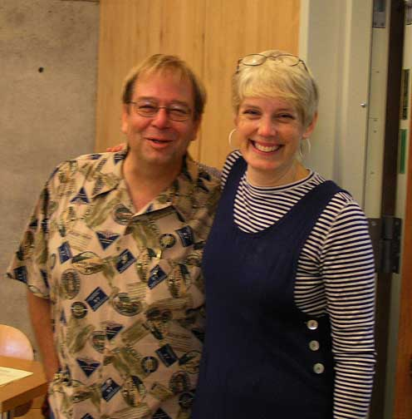

You and I will meet again   
When we're least expecting it  
One day in some far off place  
I will recognize your face  
I won't say goodbye my friend  
For you and I will meet again

Thank you for all that you have done for me. By your example, you have made me a better, more caring person. Your concern, compassion and commitment to others is unwavering. The Geoduck Teachers owe you more than you will ever know.

*Loren*