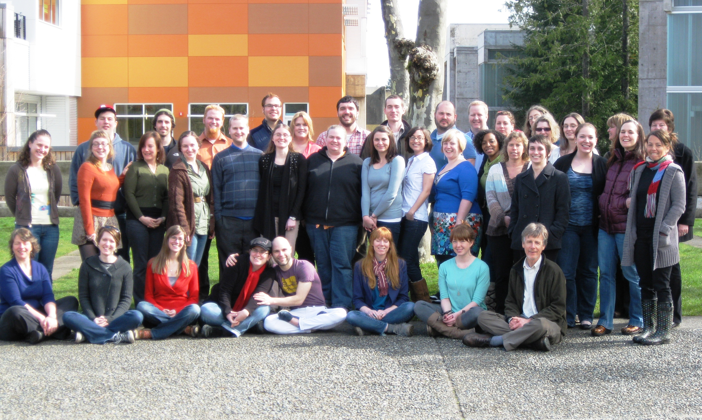

Thank you for celebrating with us, and for all of your support!



***2012* *Master in Teaching Hooding Ceremony***

**Master in Teaching**

**Hooding Ceremony**

**June 15, 2012**

***Teaching toward a Better World: Embracing the Challenges***

|  |  |
| --- | --- |
| Rose Ackman  Leah Baugh  Trygve Berg  Joe Boyer  Kellia Brinson  Hannah Bruninck  Tony Cacchione  Robin Cutler  Jason Dearborn  Nikki Dunbar  Betsy Gordon  Amy Gush  Justin Hinchcliffe  Lisa Johnson  Kyle Jutte  Bridget Kameen  Krystle Laughter  Benjamin Lee  Kayla Lehman  Matt Lester  Cara MacMillian  Linda Merwhirter  Jennifer Pasternak    Justin Poland  Ingrid Pugh-Goodwin  Starr Smythe  Kasinda Starmer  Emily Statler  Katrina Stern  Matt Stolz  Jody Tahja  Robin Tuckett  Sandra Warren  Rebecca Watts  Kobi Wilson  Kate Winkley | *Elementary Education, Visual Arts*  *Middle Level Humanities*  *Middle Level Science, Visual Arts*  *Secondary Social Studies*  *Visual Arts*  *Elementary Education*  *Secondary English Language**Arts*  *Middle Level Humanities, Elementary Education*  *Secondary Science*  *Secondary English Language**Arts*  *Secondary English Language**Arts*  *Elementary Education*  *Secondary Science*  *Elementary Education*  *Secondary Social Studies*  *Elementary Education, Visual Arts*  *Elementary Education*  *Secondary Science*  *Middle Level Humanities, Drama*  *Secondary Social Studies*  *Elementary Education*  *Secondary English Language Arts*  *Elementary Education,*  *Special Education*  *Secondary English Language Arts, Drama Drama Drama*  *Middle Level Humanities*  *Elementary Education*  *Secondary English Language Arts, Drama Drm DramaDrama*  *Elementary Education*  *Elementary Education,*  *English Language Learners*  *Elementary Education*  *Secondary English Language Arts*  *Secondary English Language Arts, Drama*  *Elementary Education*  *Secondary Science*  *Elementary Education, Special Education*  *Middle Level Humanities,*  *Elementary Education* |

“Education is the most powerful weapon which you can use to change the world”

-Nelson Mandela

**Order of Events**

Dr. Les Purce, President of TESC *Welcome Address*

Clover Park High School *Haka Performance*

Dr. Sherry Walton, Director of the MiT program *Faculty Address*

Justin Poland & Kasinda Starmer, *Theatrical Performance*

Dr. Andrew Gilbert with Matt Stolz, *Faculty Address*

Ingrid Pugh-Goodwin, *Spoken word performance*

Dr. Scott Coleman, *Faculty Address*

Lisa Johnson, *Dance*

Dr. Heather Bandeen, *Faculty Address*

Dr. Anita Lenges, *Closing Address*

**Hooding of the Graduates**

Please join us following the ceremony for lunch,

with a slideshow by Leah Baugh