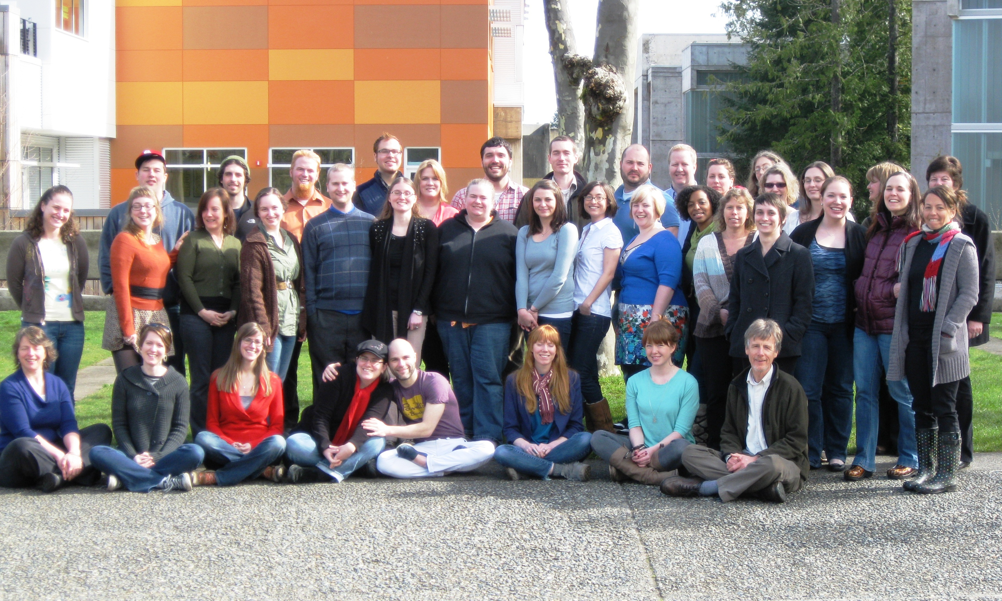

Thank you for celebrating with us, and for all of your support!



***2012* *Master in Teaching Hooding Ceremony***

**Master in Teaching**

**Hooding Ceremony**

**June 15, 2012**

***Teaching Toward a Better World: Embracing the Challenges***

|  |  |
| --- | --- |
| Rose Ackman  Leah Baugh  Trygve Berg  Joe Boyer  Kellia Brinson  Hannah Brunink  Tony Cacchione  Robin Cutler  Jason Dearborn    Nikki Dunbar  Betsy Gordon  Amy Gush  Justin Hinchcliffe  Lisa Johnson  Kyle Jutte  Bridget Kameen  Krystle Laughter  Benjamin Lee  Kayla Lehman  Matt Lester  Cara MacMillian  Linda Merwhirter  Jennifer Pasternak  Justin Poland  Ingrid Pugh-Goodwin  Starr Smythe  Kasinda Starmer  Emily Statler  Katrina Stern  Matt Stolz  Jody Tahja  Robin Tuckett  Sandra Warren  Rebecca Watts  Kobi Wilson  Kate Winkley | *Elementary Education, Visual Arts*  *Middle Level Humanities*  *Middle Level Science, Visual Arts*  *History, Social Studies,*  *English Language Arts*  *Visual Arts*  *Elementary Education*  *English Language**Arts*  *Elementary Education,*  *Middle Level Humanities*  *Science, Earth and Space Science,*  *Middle Level Mathematics*  *English Language**Arts*  *English Language**Arts*  *Elementary Education*  *Chemistry, Science*  *Elementary Education*  *Social Studies*  *Elementary Education, Visual Arts*  *Elementary Education*  *Biology, Science*  *English Language Arts, Theater Arts*  *Social Studies*  *Elementary Education*  *English Language Arts, Social Studies*  *Elementary Education, Special Education*  *Middle Level Humanities, Theater Arts Drama Drama*  *Middle Level Humanities*  *Elementary Education*  *English Language Arts, Theater Arts Drm DramaDrama*  *Elementary Education*  *Elementary Education,*  *English Language Learners*  *Elementary Education*  *English Language Arts*  *English Language Arts, Theater Arts*  *Elementary Education*  *Science, Biology*  *Elementary Education, Special Education*  *Middle Level Humanities,*  *Elementary Education* |

“Education is the most powerful weapon which you can use to change the world”

-Nelson Mandela

**Order of Events**

Dr. Sherry Walton, Director of the MiT program *Welcome Address*

Dr. Les Purce, President of The Evergreen State College

Clover Park High School *Haka Performance*

Justin Poland, Kasinda Starmer, Kobi Wilson, & Robin Tuckett *Theatrical Performance*

Dr. Andrew Gilbert with Matt Stolz, *Faculty Address*

Ingrid Pugh-Goodwin, *Spoken word performance*

Dr. Scott Coleman, *Faculty Address*

Lisa Johnson, *Dance*

Dr. Heather Bandeen, *Faculty Address*

Dr. Anita Lenges, *Closing Address*

**Hooding of the Graduates**

Please join us following the ceremony for lunch,

with a slideshow by Leah Baugh