Thank you families and friends for all of

your love and support!

We could not have done it without you!

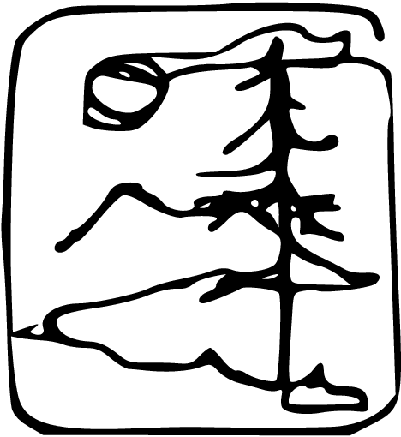

Program by Chelsea Whitaker and Kefi Andersen

The Evergreen State College

Masters in Teaching

Class of 2009-2011

**Thinking Globally, Teaching Locally: Educating for Active Citizenship**

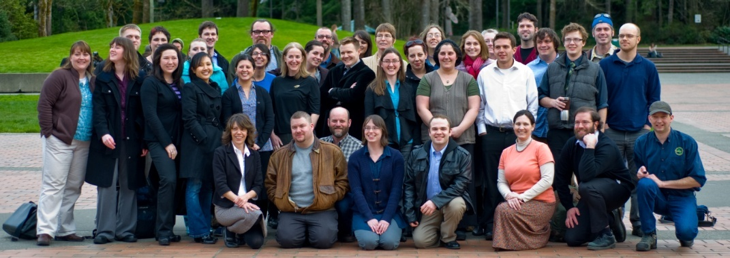

Masters in Teaching Hooding Ceremony

June 10, 2011

**Masters in Teaching Hooding Ceremony**

**June 10, 2011**

Procession

Mike Fekete

*Not Above Not Below*

Sherry Walton

*Opening Remarks*

Les Purce

*Words from the President*

James Gardner

*Friends, Teachers, Countrymen*

Mindy Ross

*A Found Poem for New Teachers*

Faculty Member Gery Gerst

*The Five Things Students Need*

Allison, Kelsey, and Monear

*Reflecting on Our Reflecting During this Period of Reflection*

Faculty Member Michael Vavrus

*Toto, I've a Feeling We're Not in Kansas Any More*

Reyna Jasmer

*A Letter from a Student Teacher to a Mentor Teacher*

Leif Hedenskoog

*Teaching is Personal*

Faculty Member Sonja Wiedenhaupt

*Reflections*

Chelsea Whitaker

*Kids*

Faculty Member Jana Dean

*A Story*

David Hunter

*It’s Not Education*

Hooding of Graduates

Closing Comments

*Slideshow*

Created by Kelsey Sutich

Potluck

**MIT Class of 2011**

Kefi Andersen – English Language Arts

Brad Boer – Visual Arts & Mid Level Math

Adriana Caviedes-Guillen – Spanish & ELL

Sasha Hawthorn – Mid Level Math

Rachele Chertok – Elementary Education

Toby De Luca – Elementary Education & Bilingual Education

Marc DeArmond – Elementary Education & Mid Level Humanities

Holly Deatherage-Larsen – French

Jeremy Dempsey – Elementary Education

Monear Fatemi – English Language Arts

Michael Fekete – Mid Level Humanities

James Gardner – History & Social Studies

Kimberly Gregg – Social Studies

Jen Hamilton – Mid Level Science

Leif Hedenskoog – Theatre Arts & English Language Arts

Carrie Hockman – Visual Arts & English Language Arts

Andrew Hoy – Mid Level Humanities & English Language Arts*

Anne Hundley – Elementary Education & Dance*

David Hunter – English Language Arts & Social Studies

Reyna Jasmer – Elementary Education & Mid Level Humanities

Deborah Jordan – German & English Language Arts

Dom Kehoe – Mid Level Science & Earth and Space Science

Amanda Kirkland – Elementary Education & Special Education*

Ryan Leacy – Social Studies & History

Sarah Maiava – Elementary Education

Nick O’Neill – Spanish

Andrew Olmsted – English Language Arts

Doug Richert – Elementary Education

Mindy Ross – English Language Arts

Cleome Rowe – Biology, Science, & Mid Level Math

Challys Samson – English Language Arts & ELL

Josh Simpson – Social Studies, History & Mid Level Humanities

Allison Smith – English Language Arts

Kathleen Stidham – Elementary Education & Mid Level Humanities

Kelsey Sutich – Elementary Education & Mid Level Humanities

Christie Tran – Visual Arts & Reading

Chelsea Whitaker – English Language Arts & Social Studies*

*Finishing in Fall 2011

**Faculty**

Jana Dean, Chris Ramsey-Sharp,

Sonja Wiedenhaupt, & Michael Vavrus