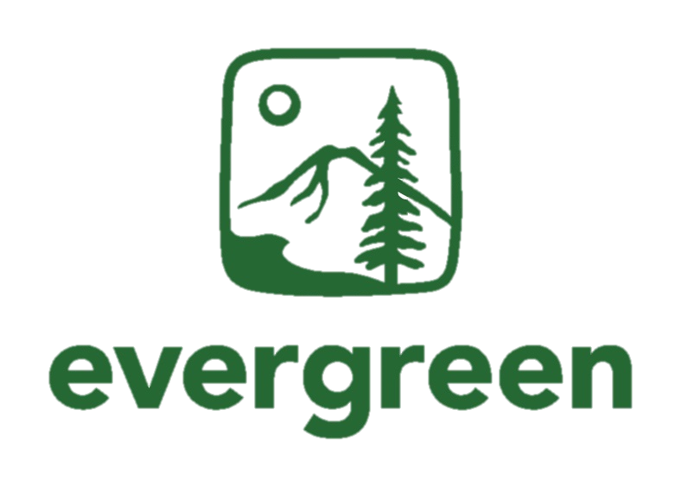

The Evergreen State College
Financial Aid Office

Graduate Statement of Undergraduate Requirements

Student’s Name Student ID Number Date

- Please indicate the graduate program for which the student is completing these undergraduate requirements.

Master in Teaching (MIT)

Master of Environmental Studies (MES)

Master of Public Administration (MPA)

- List below the undergraduate requirements to be completed and the term for which the student is/will enroll for these course(s).

CRN | Course/Program description | Number of credits to complete | Term (quarter)

Graduate Program Certification:

The undergraduate credits listed above are required for this student to complete their graduate degree.

Graduate Program Signature Name (please print) Date

