**Standard for closing applications**

5.29.18

New with Radius processes

(first draft)

The process to communicate that the application is closing and how to close the application form to applicants.

Graduate Programs will discuss within their programs when they wish to close their applications. They will also decide how they want to close their applications; gradually or at a clean cut-off deadline.

We work closely with Josephine Bernier, CRM Manager, to request changes to the Radius application form. We work with our Evergreen webteam (Justin McDowell) to request changes to our graduate program web pages (and with our graduate program staff who can update program web pages).

Timeline for closing applications:

1. Finalize with graduate program director the following:
   1. Date requested to close application
   2. Confirm which option you will pursue:
      1. no more submissions allowed

– or -

* + 1. you will allow started apps to be submitted
       1. If allowing started apps to be submitted, confirm date to finalize any application submissions

1. Send request to CRM Manager (Jo) to either remove all ability to submit an application or just remove the option to begin a new application (allow previously started apps to be submitted)
2. Work with CRM Manager to send request to webteam to remove the graduate program’s application hyperlink from all pages. If you want applicants to continue to submit applications, request they add the returning applicant link and appropriate wording to your web pages. If you want applicants/admits with submitted applications to be able to continue to view their application materials through the Self Service Center, request the returning applicant link and appropriate wording on your web pages.

There are a few examples of options you can choose when requesting to close your applications:

OPTION 1 – completely remove the chance for anyone to submit an application

* Request that Jo update the Radius application form to not allow any new submissions (but leaves the ability for applicants to still view the application in the Self Service Center).
* Request the hyperlink to the Radius application be removed from all web pages (main web page, application and requirements web page, any other links added to other pages)
* Request to the webteam to update the text on your pages (main and apply) to show that the application is closed and when the next application will open.

OPTION 2 – remove the chance for a new application to be started but a prospective applicant with an application form started may still continue and submit the application

* Request the hyperlink to the Radius application be removed from all web pages (main web page, application and requirements web page, any other links added to other pages)
* Request to the webteam to update the text on your pages (main and apply) to show that the application is closed to new applications and when those who have a started application must submit the application.
* Confirm there is a link to the Self Service Center to log into the application already started

OPTION 3 - MPA – close one or two concentrations but leave at least one concentration open for new applicants

* Jo updates the Radius application form to remove the concentration options that have closed (a new applicant can start an application but cannot choose the closed concentrations).This doesn’t stop applicants who had previously started their applications when those concentrations were still open from submitting an application for one of the closed concentrations.)
* Request to the webteam to update the text on your pages (main and apply) to show that the application is closed for specific concentrations and which concentration is still open. Give timeline of when this concentration will close.

Amanda’s Note – it may be helpful for the ADs to send out an announcement (campaign) to all app form started applicants to let them know the application is closing/closed.

After the applications are closed, Jo or Amanda change the Application Status field for un-submitted applications status from ”Application Form Started” to “Application Term Closed” to signal to the applicant that the application is no longer active.

Examples of graduate program web pages with application closing information/text:

At bottom of Main MES web page:

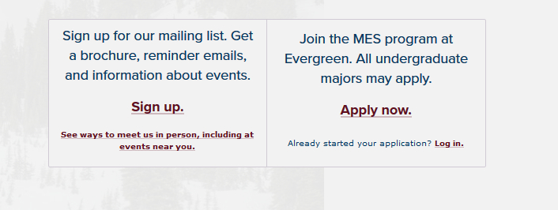

“Apply now” redirects to the [MES Application and Requirements](http://www.evergreen.edu/mes/apply) page (doesn’t go to the MES application form in Radius)

“Log in” link is the returning user Self Service Center page (not linked to a new application)

<http://www.evergreen.edu/mes/apply>

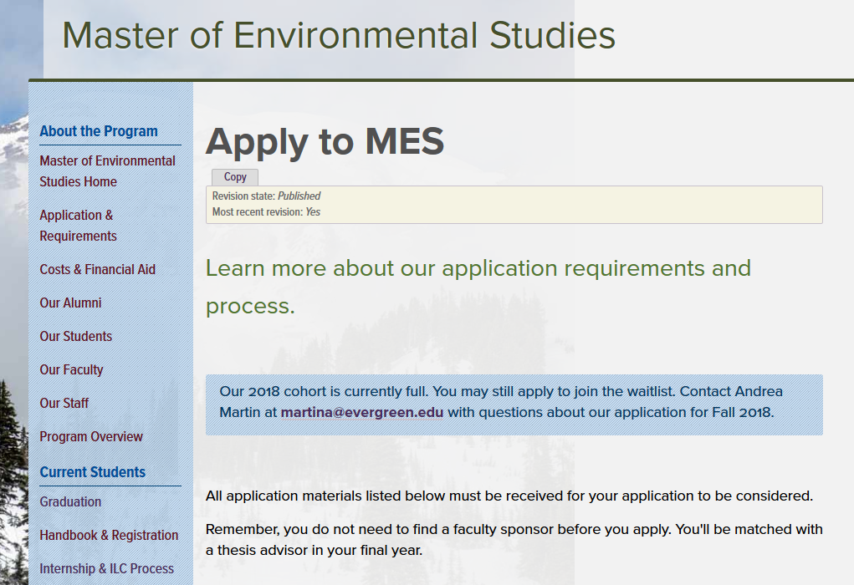

Example of MiT:

From MiT main page:

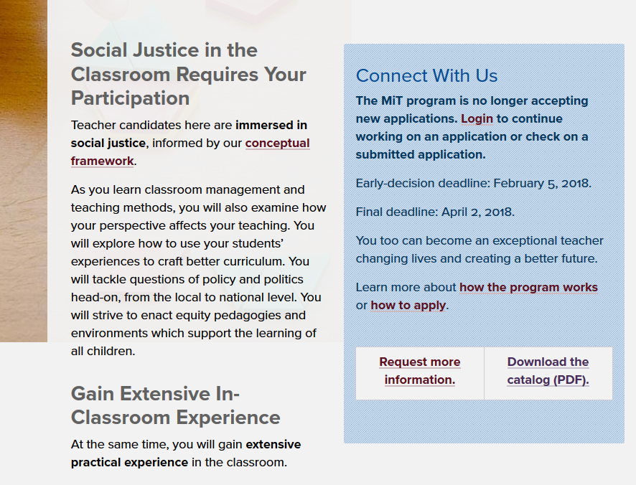

“Login” link takes user to the general Self Service Center login to access an application already started: <https://evergreenstatecollege.hobsonsradius.com/ssc/zx671mkk0x6G0x670GA71.ssc>

Application and Requirements page:

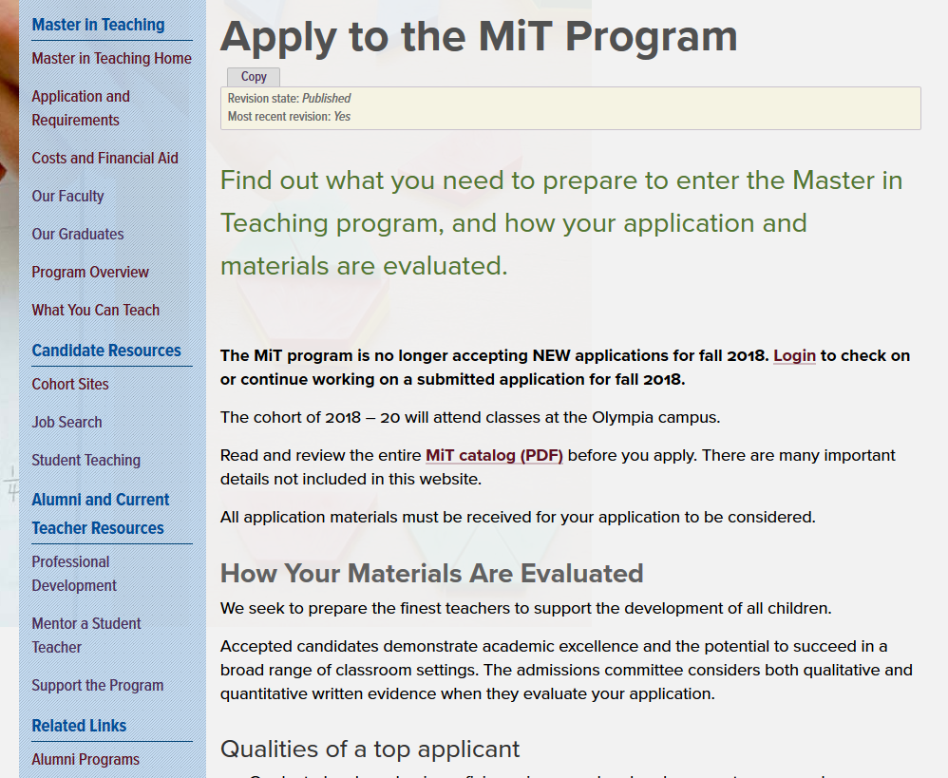

Example of MPA:

From MPA main page:

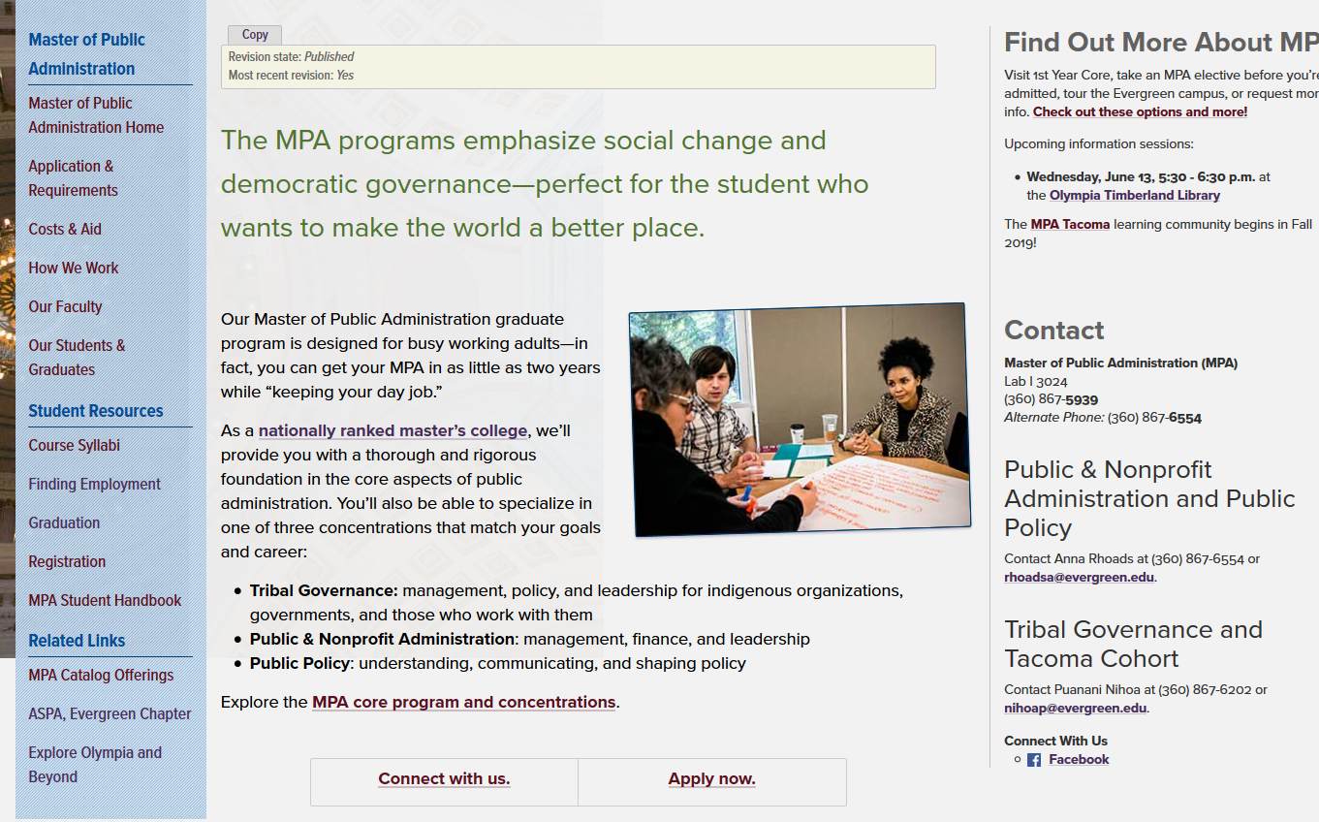

Link for “Apply now” takes user to the Application and Requirements page

From MPA Application and Requirements page:

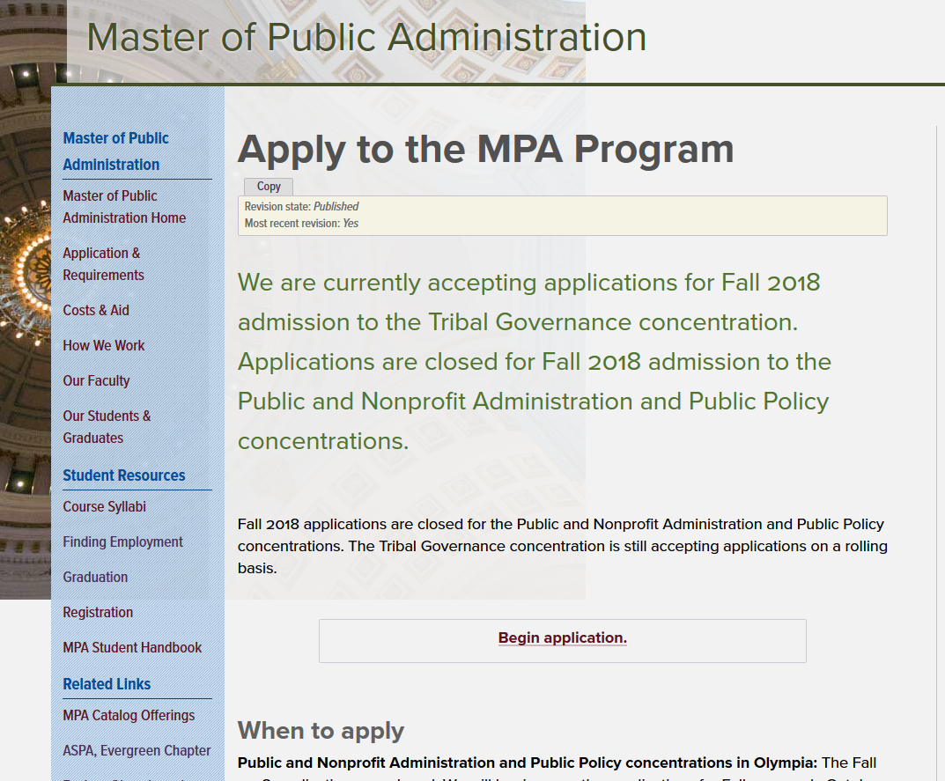

“Begin application” link takes user to the Fall 2018 MPA application form in Radius (must first set up account in Self Service Center, then MPA application is available)

MPA Fall 2018 application form – creates MPA application in Self Service Center using this application form link:

<https://evergreenstatecollege.hobsonsradius.com/ssc/aform/BfC70rC78670x6700oB00l.ssc>

