***Application Fee Processing & Application Fee Waiver Processing***

APPLICATION FEE PROCESSING:

1. Applicant follows the steps to make payment in the Self Service Center after the application is submitted.
2. GPAC checks in Radius to confirm application in “Application – Not Verified” status has paid the application fee by searching in the Application – Payment Gateway Transaction Log tab for info on CASHNet transaction details

APPLICATION FEE WAIVER PROCESSING:

The applicant requests an application fee waiver through the online application system. See below for options provided in Radius graduate application fee waiver section:

Example of Application Fee Waiver options in Fall 2017 Graduate Application:

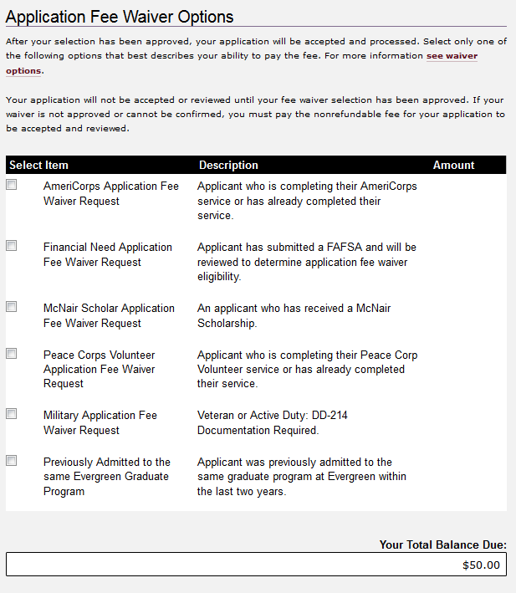

_____________________________________________________________________________________

Information from CRM Project Manager as we developed the application fee waivers in Radius (8/2016)

Grad Programs – CRM Application Fee Waivers (**Notes:** #5 and #11 are for internal use only)

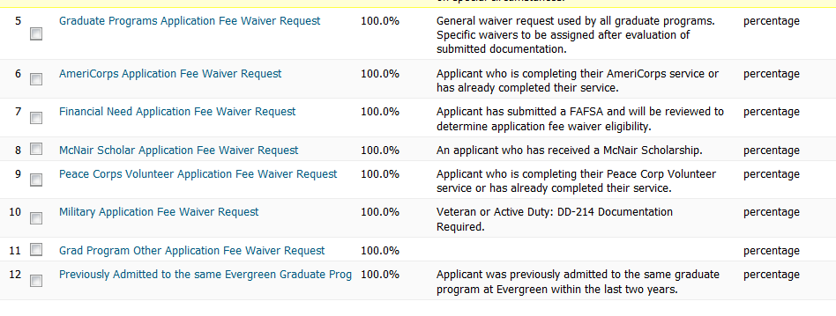

Sample text for application

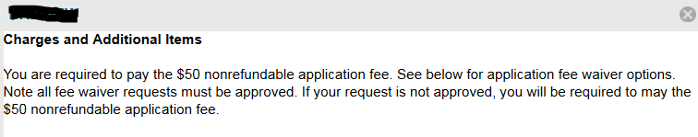

Discounts:

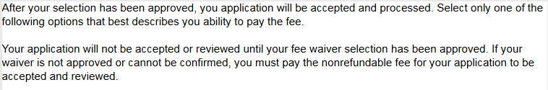

_____________________________________________________________________________________

Fee waiver processing - *PRIOR* TO STARTING APPLICATION IN RADIUS:

* The prospective applicant can provide documentation prior to submitting their application in Radius by sending the required documents to [graduateadmissions@evergreen.edu](mailto:graduateadmissions@evergreen.edu) . (direct prospective applicant to the Graduate Studies Application Fee Waiver website for instructions: <http://www.evergreen.edu/graduatestudies/applicationfeewaiver> )
* GPAC will receive the documentation and forward to the appropriate grad program AD for review
* AD will review eligibility and reply to GPAC with approval or denial
* GPAC will hold the approval information and wait for the prospective applicant’s application to be started in Radius. (When application form started, follow instructions below for updates to the application.)
* GPAC will notify the prospective applicant of the approval or denial and give instructions on how to formalize the application fee waiver request within their graduate application in the online system.

Fee waiver processing - **AFTER** STARTING APPLICATION IN RADIUS:

* The applicant requests an application fee waiver through the online application system
* GPAC reviews un-submitted and submitted applications for application fee waiver requests
* GPAC reviews if applicant provided supporting documentation for application fee waiver request
  + If missing supporting documentation, GPAC contacts applicant to request required documentation
* GPAC receives the documentation and forwards to the appropriate grad program AD for review
* AD will review eligibility and reply to GPAC with approval or denial
* GPAC will update the prospective applicant’s online application (check box “Application Fee Waived” and update “Fee Waiver Approved Date”)

QUESTION: Can we streamline the process to wait to add the fee waiver approval until after the application is submitted? This would help with fewer pieces for GPAC to track during busy application cycle.

NOTE – If application submitted but application fee waiver cannot be processed:

* Applicants are expected to read the instructions carefully in the application and the Graduate Studies website – applicants will receive one reminder to submit documentation for application fee waiver
* If application fee waiver documentation is still missing 2 weeks prior to application deadline
  + Applicants sent a reminder of Graduate Program Application DEADLINE at least 2 weeks prior to application deadline and request to submit documentation asap. Also give suggestion that they can remove their fee waiver request and choose to pay the application fee online if they are worried about missing the deadline.
* If not enough time to process the application fee waiver prior to the application deadline,
  + Recommend to applicant to pay the application fee instead to ensure application will be considered on time and will be processed

**Process for determining eligibility for graduate application fee waiver request:**

**AmeriCorps Application Fee Waiver Request**

WHO: (Applicant who is completing their AmeriCorps service or has already completed their service)

HOW:

Current:

“Have your current supervisor send an email indicating you are currently serving, including your intended term of service and service dates.”

Alums:

“Email a copy of your AmeriCorps Service Letter found at [my.americorps.gov](https://my.americorps.gov/mp/login.do). Please send a copy for each completed term of service.

International Earth Corps alums must have Earth Corps staff send an email verifying term of service and service dates.”

AD’s review process:

* Check if documentation provided confirms dates of service
* Notify GPAC if eligible or not eligible for Financial Need app fee waiver
* (QUESTIONS –
  + What is the minimum number of months of service required?)

**Financial Need Application Fee Waiver Request**

WHO: (Applicant has submitted a FAFSA and will be reviewed to determine application fee waiver eligibility)

HOW: “These waivers are limited by each program. Please be sure to have completed your [FAFSA](http://www.evergreen.edu/financialaid/2017-2018-fafsa.htm) in a timely manner in order for the Financial Aid Office to document your need prior to application review deadlines.”

AD’s review process:

* Check in Banner (ROARMAN?) for evidence that applicant has submitted FAFSA
* Check if Expected Family Contribution (EFC) is $0.00 (MPA)
* Notify GPAC if eligible or not eligible for Financial Need app fee waiver
* (QUESTIONS –
  + How long does it take from when an applicant submits their FAFSA to when FIN AID process the FAFSA load?
  + When is FIN AID processing FAFSA load data? (multi per day, daily, weekly, ?)
  + How long after the FAFSA load is entered into Banner will FIN AID process the FAFSA and have the EFC available?
  + What are other ways ADs determine financial need?
  + When is our cut-off for accepting Financial Need waiver requests?
  + Do all programs want to use the same EFC of $0.00?)

**McNair Scholar Application Fee Waiver Request**

WHO: (An applicant who has received a McNair Scholarship)

HOW: “Have your institution's McNair coordinator send an email confirming you are a McNair scholar.”

AD’s review process:

* Check if documentation provided confirms scholarship
* Notify GPAC if eligible or not eligible for Financial Need app fee waiver

**Peace Corps Volunteer Application Fee Waiver Request**

WHO: (Applicant who is completing their Peace Corps Volunteer service or has already completed their service)

HOW: “Email a copy of your [Description of Service (DOS) Statement](https://www.peacecorps.gov/returned-volunteers/support-services/certifications-service/) or [Certification of Service for Employment Services](https://www.peacecorps.gov/returned-volunteers/support-services/certifications-service/).”

AD’s review process:

* Check if documentation provided confirms dates of service
* Notify GPAC if eligible or not eligible for Financial Need app fee waiver
* (QUESTIONS –
  + What is the minimum number of months of service required?)

**Military Application Fee Waiver Request**

WHO: (Veteran or Active Duty: DD-214 Documentation Required)

HOW: “Email a copy of your [DD Form 214 (Report of Separation)](http://www.archives.gov/veterans/military-service-records/about-service-records.html) indicating that you were honorably discharged.”

AD’s review process:

* Check if documentation provided confirms dates of service
* Notify GPAC if eligible or not eligible for Financial Need app fee waiver
* (QUESTIONS –
  + What is the minimum number of months of service required?)

**Previously Admitted to the same Evergreen Graduate Program**

WHO: (Applicant was previously admitted to the same graduate program at Evergreen within the last two years)

HOW: “If you have previously been admitted to the same graduate program within the last two years but did not enroll, you can choose the option to waive the application fee for your second application submittal to the program.”

_____________________________________________________________________________________