**Standard for Withdrawing an Application**

*This process in Banner is the same for deferring a student for one year.*

Log into Banner.

Where it says ‘Go To’ - Type WTD

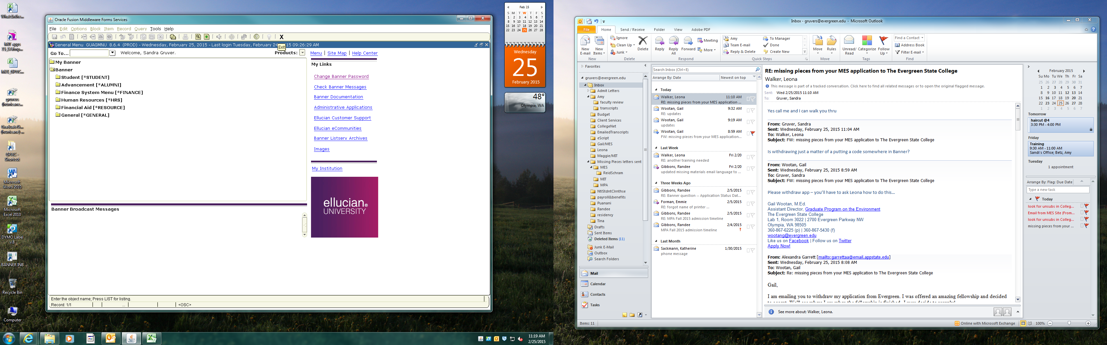

Enter student ID, alt-page down (Next Block) to get to *Decision Data* block

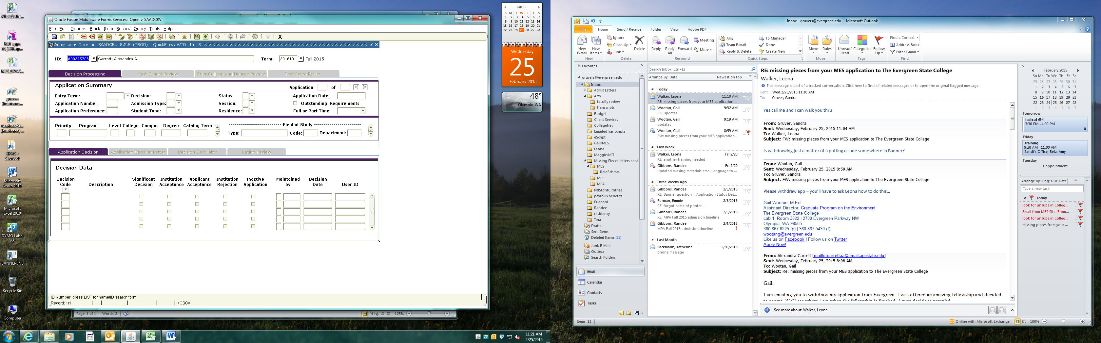

In Decision Data block, enter AW in Decision Code field

If student was *admitted but not paid*, use EW

If student was *admitted and paid*, use code PW

Press F10 to Save (or click Save button)

Exit to next screen

In the next screen, Alt + page down (next block), tab over and down to Application Status, enter W

Press F10 to Save, press X to Exit

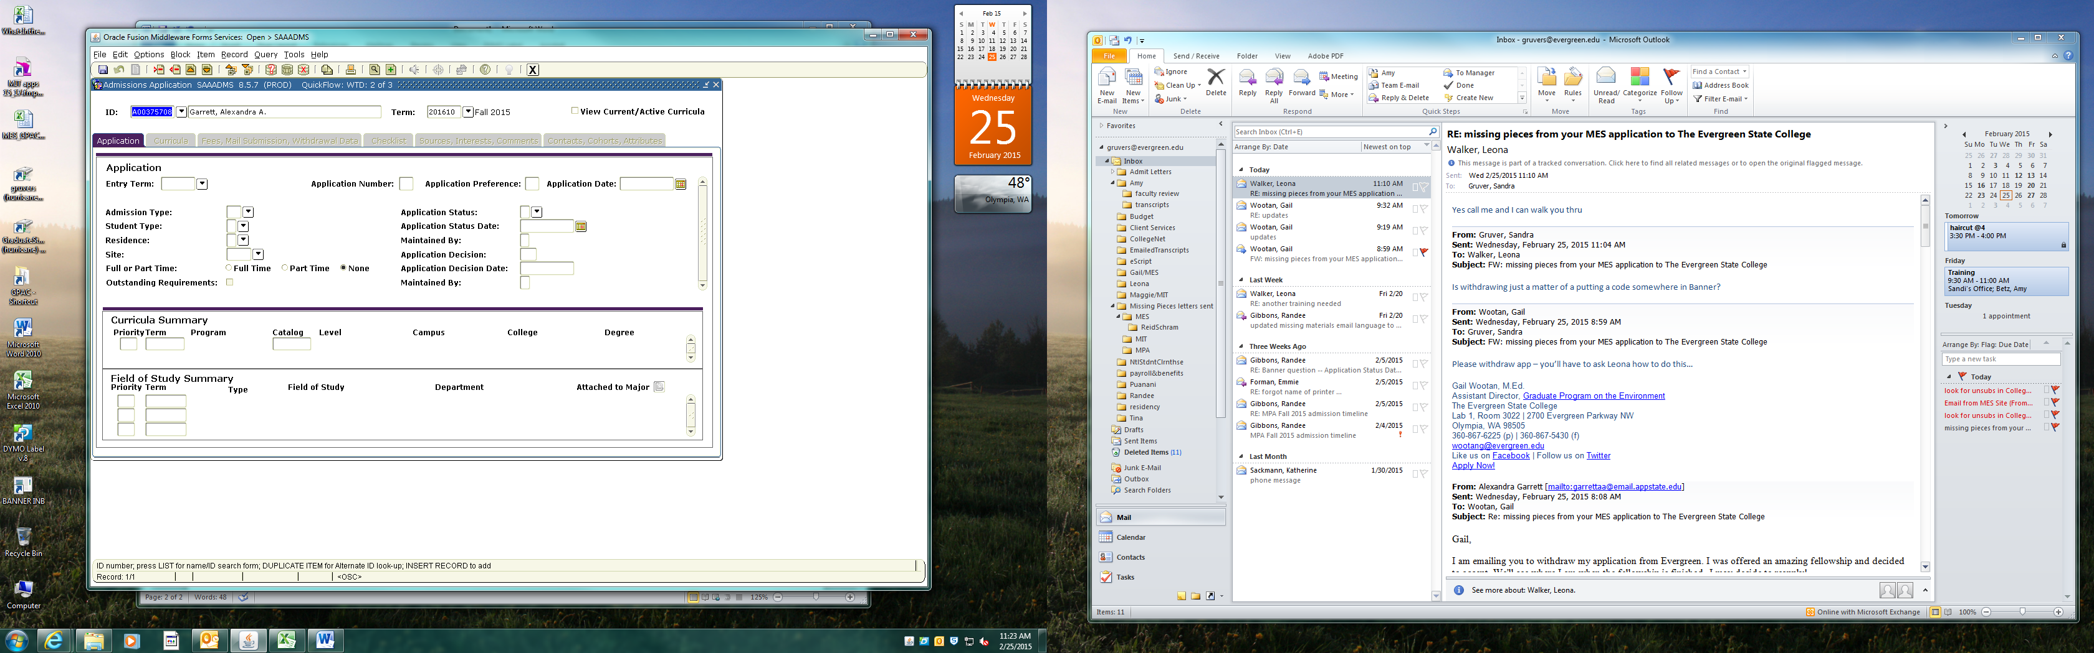

Exit takes you to the last screen (below)

If applicant had been admitted, do Next Block (alt+page down)

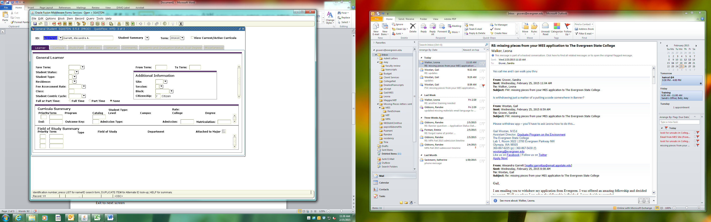

Enter WD in Student Status, Save (F10), press X to exit.

If this screen cannot be completed because you get an error message at bottom of screen, email Lori Klatt or Leona Walker in Registration asking for help to complete the process. Admitted students with registration activity require Registration colleagues to update this form (SGASTDN).

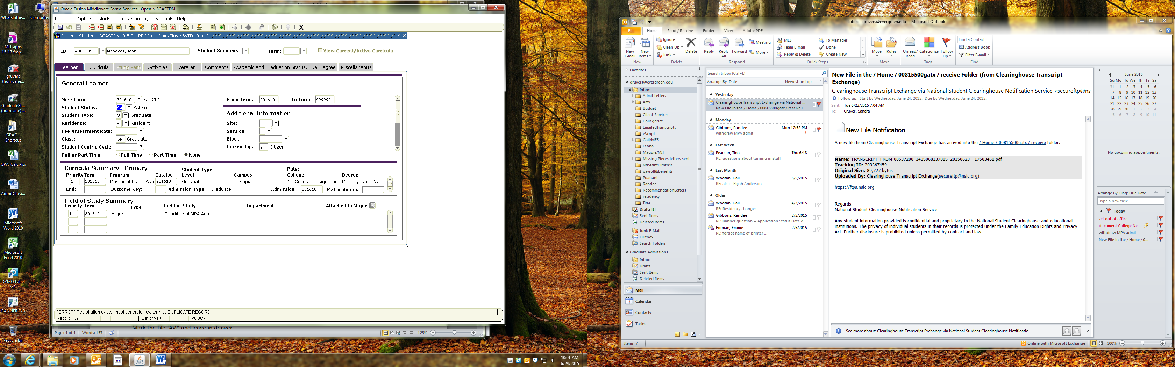

Mark the file ‘AW’ (or EW or PW) and leave in drawer it in the Withdrawn section.