**Steps in processing graduate programs application fee waiver requests**

October 2016 (with Graduate application in Radius)

OVERVIEW:

Graduate Programs Application Fee Waiver types:

* Current AmeriCorps or Earth Corps Members
* AmeriCorps or Earth Corps Alums
* McNair Scholars
* Returned Peace Corps Volunteers
* U.S. Military Veterans
* Financial Need
* Previous Graduate Program Admittance

Information given in “Charges and Additional Items” section of GR application:

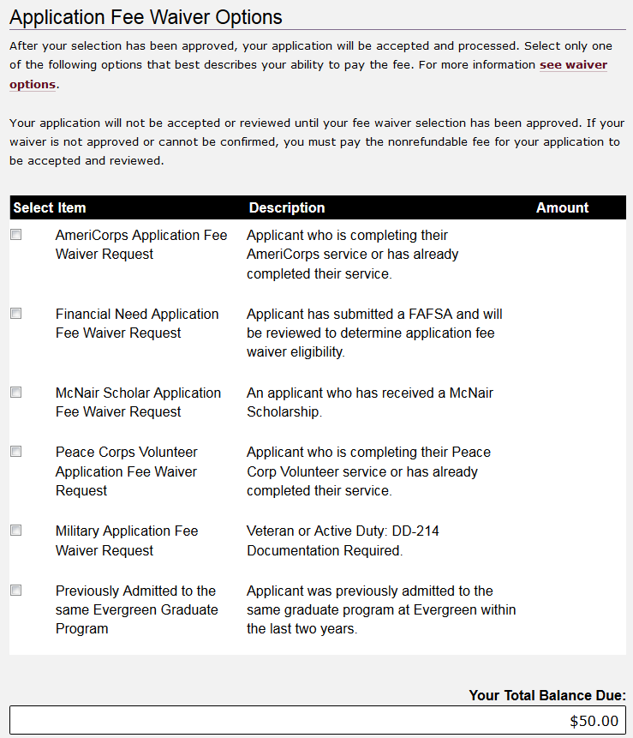

WEBSITES:

Graduate Studies Website: shared Graduate application fee waiver site, with hyperlink in application

<http://www.evergreen.edu/graduatestudies/applicationfeewaiver>

Graduate Programs individual Websites: links to shared Graduate application fee waiver site (make sure they are updated)

Applicants are directed to submit supporting documentation to the Graduate Admissions email address:

[graduateadmissions@evergreen.edu](mailto:graduateadmissions@evergreen.edu)

Graduate Admissions processing:

1. Check Radius listviews daily for applicants with pending application fee waiver requests:
   * “AMM - Daily Applications - Incomplete w Discount”
   * “AMM - Daily Applications - Not Verified w Discount”
2. If application fee waiver requests pending…
   * Check if Evergreen has received documentation:
     + GPAC
     + ADs
   * If supporting documents were not received:
     + Send template email to applicant – Grad Admissions received request, need documentation in order to process request, application will not be reviewed until fee waiver request is approved OR payment is received.
     + Send follow up email at least 3 weeks prior to application deadline if still unresolved…
   * If supporting documents were received:
     + Go to applicant’s Contact record. Go to Application tab. 
     + On far right side, click on “Action” to show drop down menu.
     + 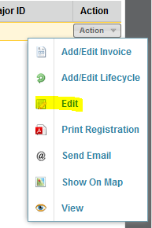 Click on “Edit” and in the Application Status Information section, Click on “Application Fee Waived” to fill check box.

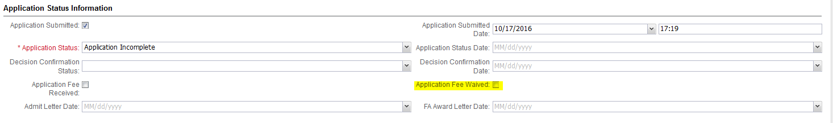

Applicant submits application fee waiver request through Radius when submitting application.

1. Application Fee Waiver types:
2. Applicant submits FAFSA for Financial Need Application Fee Waiver Request
3. Applicant submits verification document for other Application Fee Waiver Requests