1. **Radius Basics**
   1. Primary Module listing with dropdown list

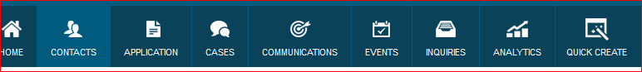

* 1. Global Search bar (allows searching in any module from within any module) is found at the very top of your screen. Note: this search has a viewing limitation of 50 records and does not refresh to a larger list.

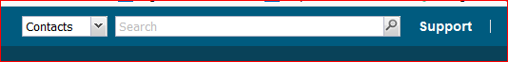

* 1. Listview (report) Search bar: allows searching within the listview you have open. This is found mid-page to the right of the list you are in.

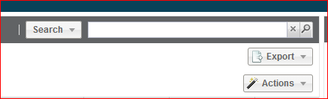

And provides a field search option based on the listview column headers (this varies by module and by listview). Adding other columns to your listview may provide additional search options.

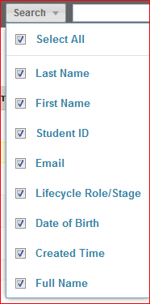

To export a listview, select EXPORT at the top right of the listview. Note: not all profiles will have permisisons to export listviews. Select the desired file format, Excel is preferred

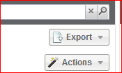 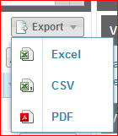

* 1. **Search wildcard** is * (asterisk) and can be used in any location plus multiple times within one search string. The wildcard also works from within the listview search.

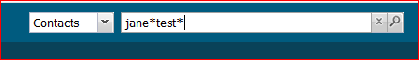

* 1. Adding tabs to your record view is done by selecting **RELATED INFORMATION** in the mid-right area of your screen. Follow the lighter grey bar to the right side of the screen. Click on the gray triangle to show the dropdown list



The drop down will be slightly different depending on the module you are in. The Contact Module will be the most expansive. Related Information is available in other modules including the Application Module, Event Module, etc.

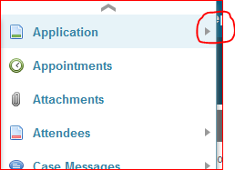Some modules will also have sub-dropdown menus

An example of additional tabs added to the Contact screen of a record.



* 1. Left **Navigation** panel: Is segmented by Recent Items, User Notifications, and Calendar.
     1. Recent Items = a listing of what you have recently viewed and will include person records, listviews, targets, campaigns (to name just a few)
     2. User Notifications = various system generated notifications
     3. Calendar = Radius specific calendar for tracking tasks, campaigns, communication plans, etc.
  2. Right **Tools** panel: This will change depending on what screen you are in.
     1. When in a listview, it will show you the view criteria, filters, sorting, etc.
     2. When in a record, it will show you the various options you can perform from that screen. This is essentially a series of shortcuts such as email, etc.

1. **Where do I find things**
   1. Contact Record Screen (key fields)

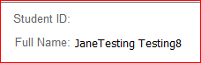

Student ID = Banner ID; also listed is Confidential status

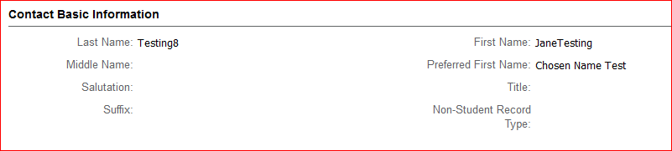

Other important tracking codes and information is found in the following sections (toward the bottom of the Contact Module.

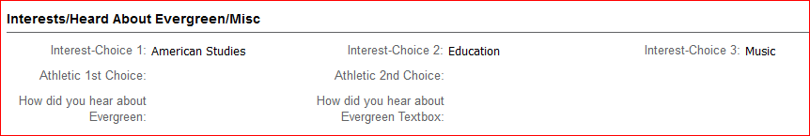

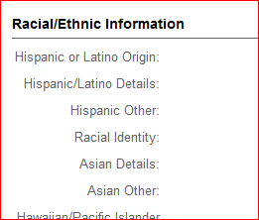

Application Record Screen (key fields) - the following shows a sorted and group view of the Application tab on a Contacts record.

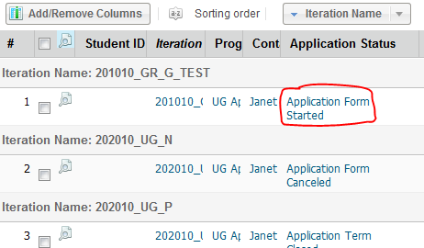

* 1. To access/view a specific application (iteration), click the **Application Status** (circled above). This will open the Application screen for that specific application. 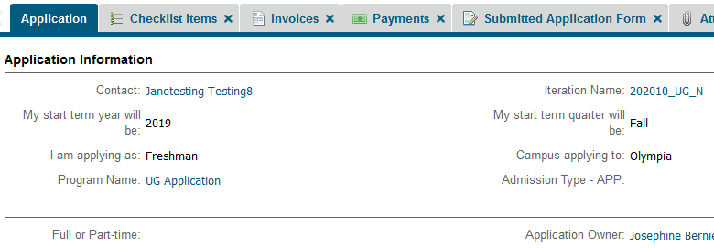
  2. Each application will contain specific data related to that term and year. The example above is related to a Fall 2019 Freshman/First Year application.
  3. You will also want to look at the following section on the application screen for other pertinent information: 