THE EVERGREEN STATE COLLEGE
GENERAL PERSON STANDARDS, POLICIES AND PROCEDURES
FOR BANNER INFORMATION SYSTEM
(Last revised 3/10/2014)

I. Searching for a Record ……………………………………………………. 2
A. Person Records
B. Vendor Records

II. Identification Numbers ……………………………………………………… 5
A. Person Identification Numbers
B. Vendor Identification Numbers
C. Creating Smart IDs for Companies (Non-Person Records)
D. Duplicate PIDMs

III. Names ………………………………………………………………………. 6
A. General Guidelines
B. Person Name Format
C. Non-Person (Vendor) Names

D. Name Change Policy and Procedure

IV. Addresses ………………………………………………………………….. 12
A.Procedure for Changing Addresses

B. General Address Format
C. Miscellaneous Formats

D. Campus, International and Military Addresses
E. Address Review and Verification Form – GOAADDR

V. Telephone Numbers ………………………………………………………. 19

A. General Guidelines

B. Telephone Type—Required

VI. E-Mail Addresses ……..…………………………………………………… 20

VII. Notification of Deceased Procedure ……………………………………. 21

VIII. Duplicate PIDM Process …………………………………………………. 21

A. Identification Procedure

B. Deletion Procedure

I. SEARCHING FOR A RECORD

A. Person Records

To avoid double PIDMs (records), always use search procedures before creating a new record.

Identification Form (APAIDEN, FOAIDEN, SPAIDEN)

In the Key Block name field,
Type Last name comma First Name, ENTER
If there is only one record, it will appear in the name field.
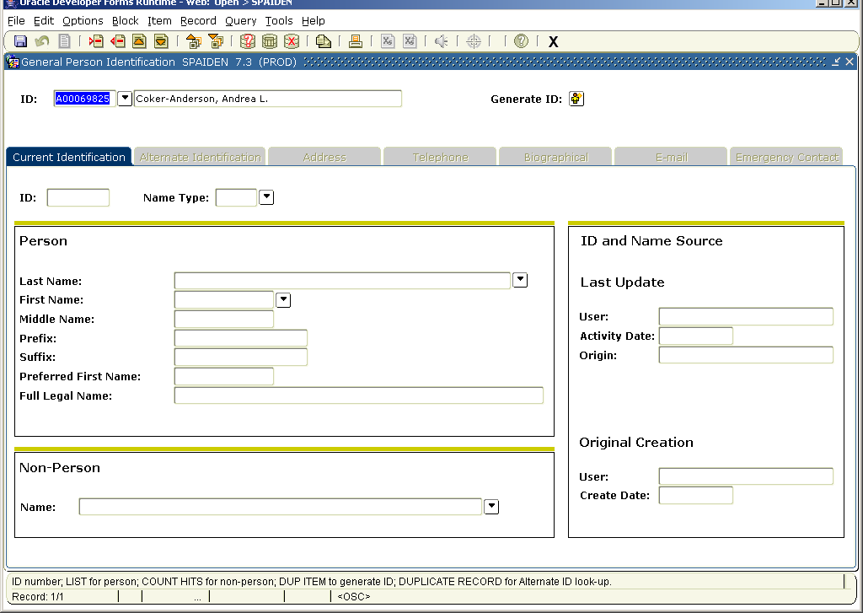
If there are multiple records with that name, the Extended Search block will appear with all of the names. Click on the name to return to the Identification Form

If no results, click on generate ID icon which will take you to the form GOAMTCH.
Choose to search a person or a non-person record by using the Matching Source menu for Person or Non Person. Enter as much or as little personally identifiable information as known. Click the Duplicate Check icon and review possible matches. If no match presents then select the Create New icon.

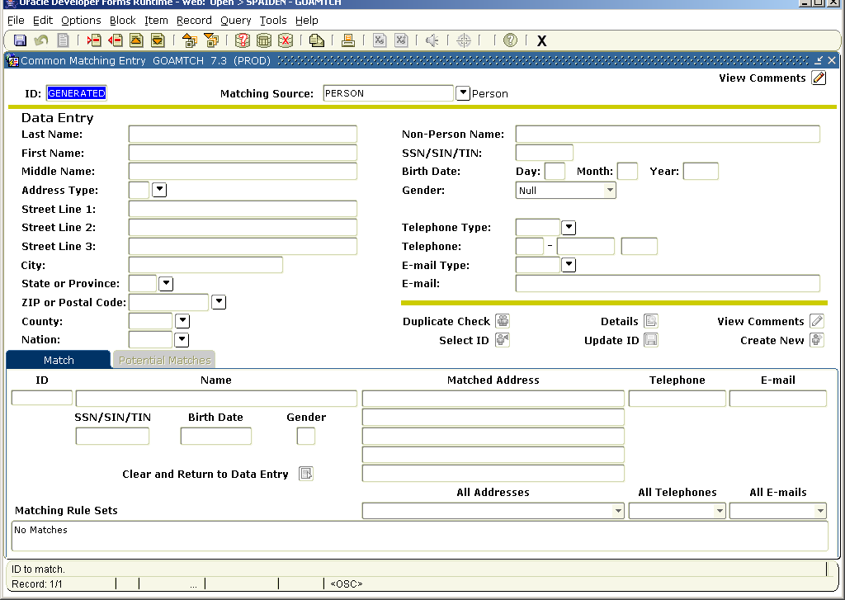

Use SOAIDEN as another resource for duplicate checking
Type in 3 or 4 letters of the Last name and % and 3 or 4 letters of the First name and % in fields.
Use upper and lower case letters
Execute Query (F8)
If name comes up, double click on I.D. to go back to the Identification Form.
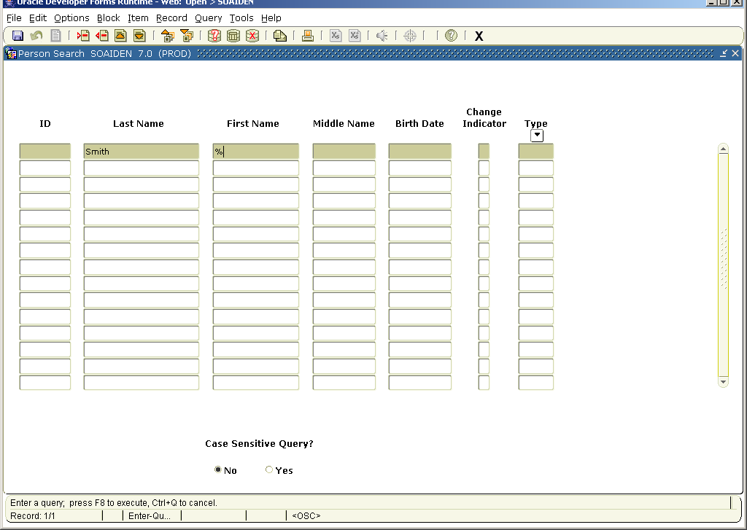

Vendor Records

Banner person and non-person demographical information is stored in tables that are shared by all modules of Banner. The forms used to access the data are specific to each module, but because the tables are shared, extra care and diligence must be used when establishing new vendors. By following the procedures below, you will insure that vendors remain unduplicated in Banner.

1. Go to the Vendor Maintenance Form (FTMVEND) and perform a search using the flashlight next to first field at the top of the form.

2. The Entity Name/ID Search Form (FTIIDEN) appears. In the Last Name field, enter the name or partial name of the company that you are searching for. Use the wildcard (%) after partial name entries to retrieve any record that begins with the letters entered.

3. Click the execute query button or press F8. The results of the search are displayed. This will display any company or person that already exists as a vendor meeting your search criteria.

4. If the vendor is a person, expand your search by clicking on the rollback button. FTIIDEN will be cleared. Remove the check from Vendor box and add the check to the All box in the top right hand corner of the form. Go to the next block by clicking the Next Block button or Ctrl-Page Down. Perform a search as described above. This will display all persons in Banner meeting your search criteria.

5. If the results display the vendor that you want, you may select it using the select button or double click on the ID Number field.

6. If you cannot find the vendor, try searching with various combinations of the name and the wildcard (%). If no match can be found, create the vendor following the instruction in Section IIB – Vendor Identification Numbers.

II. IDENTIFICATION NUMBERS

I.D. Creation or Changing
OFFICE/STAFF responsible for following: | Create ID | Change ID due to duplicate PIDM
Staff (Permanent and Temporary) | HRS | HRS
Faculty | Deans/R&R | R&R
Admission Applicant, not a current student | ADM | ADM/R&R
Financial Aid applicant only | FA | FA/R&R/ADM
Student, Active | ADM/R&R | ADM/R&R
Student, Inactive | -- | R&R
Student, Advance payment | ADM | R&R
Donors/Parents | ADV | ADV
Vendors, Vendors (Person) | PURCH | PURCH/R&R
Third Party Company | ADV | ADV
Financial Aid Lenders | FA | FA

A. Person Identification Numbers

Person IDs begin with the letter ‘A’ and are generated with one-up numbers by the Banner system. All search efforts must be done prior to generating a new ID to avoid creating a duplicate PIDM.
Persons existing in a Legacy system were converted with their Legacy ID number and were generated a new nine-digit Banner number beginning with A. The former ID number remains in the system in the Alternate Information block. New persons created are generated an ID. The Social Security Number (SSN) is recorded in the SSN field in General Person. The SSN also appears in the Alternate Information block.

B. Vendor Identification Numbers

Prior to creating a new vendor, all effort must be made to ensure that the vendor is not already established in Banner. Please refer to Section I – Searching for a Vendor Record. If no vendor record exists, create a record as follows:

Determine if the vendor is a company or an individual. If the vendor is a company, create a Smart ID for the vendor using the Vendor Maintenance Form (FTMVEND). If the vendor is a person, generate an ‘A’ number using the Vendor Maintenance Form (FTMVEND).

C. Creating Smart IDs for Companies (Non-Person records):

Smart IDs are created using the following rules:

- Only capital letters or numbers are used:
Example: Roadway Express, Inc. or C2F Inc
Input as: ROAEXP C2FINC

- Do not use spaces, hyphens, periods, slashes, or any other character or symbol that is not a letter or number:
Example: K-20 Network Services or B & H Photo, Inc.
Input as: K20NET BHPHO

- If two or more words are in the vendor name, use up to the first 3 alphanumeric characters of the first two words in the vendor name:
Example: Northwest Cable & Connector
Input as: NORCAB

- If vendor name is just one word, use up to first 6 alphanumeric characters:
Example: CH2O or Voyager
Input as: CH2O VOYAGE

- If two different vendors have the same vendor characters, use numerical sequence to identify each succeeding vendor:
Example: Michie Company or Micron Computer
Input as: MICCOM MICCOM1

- If vendor name is separated by a hyphen or a slash, treat it as two separate names:
Example: Perkin-Elmer Corporation
Input as: PERELM

- If only two characters in the first name, use only those two characters:
Example: US Welding Inc
Input as: USWEL

- Initials and Abbreviations - vendors who use initials and abbreviations as their official corporate name will be input in the same manner:
Example: BCF Office Equipment or IBM
Input as: BCFOFF IBM

- Do not use the following words as part of the vendor number:
and of at
by the academy
association international institute
department school
for with

Example: Films for the Humanities or Lumbermans of Olympia
Input as: FILHUM LUMOLY

Example: Olympia School District or Koch International Corp
Input as: OLYDIS KOCCOR

- If the vendor is a university, input the name of the university first:
Example: University of Chicago or University of Iowa
Input as: CHIUNI or IOWUNI

- Exception: Use the following:
UW University of Washington
WSU Washington State University
EWU Eastern Washington University
CWU Central Washington University

WWU Western Washington University

TESC The Evergreen State College

- Because Banner will not allow manually-generated ID numbers to begin with the same character as computer-generated ID numbers (persons in Banner have computer-generated numbers), there is an exception for vendors whose name begins with the letter 'A'. The computer-generated person ID numbers at TESC begin with 'A'. Vendor names beginning with the letter ‘A’ will be created using ‘@’ in place of the ‘A’ as the first letter:

Example: Advanced Telcom Group, Inc. or American Red Cross
Input as: @DVTEL @MERED

D. Duplicate PIDMS (Records)

Duplicate PIDMs (Persons with two IDs.) are researched in the Admissions, Financial Aid, Registration & Records, Student Accounts, Business Services, Human Resource Services and Advancement Offices to determine which number is the correct one. The incorrect number is invalidated by typing the correct ID number in the last name field. (e.g. USE ID A00012345) A dash (-) is entered for the first name.

See section VIII for the complete Duplicate PIDM procedures.

III. NAMES

Name Creation or Changing
OFFICE/STAFF responsible: | Create Names | Change Names
Staff (Permanent and Temporary) | HRS | HRS/R&R
Employee Social Security Name (Student, Temporary, Permanent, or Faculty) | -- | HRS
Faculty | DEANS | DEANS
Applicant, not a current student | ADM | ADM
Financial Aid applicant only | FA | FA
Student, Active | ADM/R&R | ADM/R&R
Student, Inactive | -- | R&R
Student, Advance payment | ADM | ADM/R&R
Donors/Parents | ADV | ADV
Vendors, Vendors (Person) | PURCH | PURCH
Financial Aid Lenders | FA | FA

Person Name Types –
The following name types are used:

ALUM | Legacy System Alumni ID (RE)
CONV | Legacy System Student ID
MAID | Maiden Name
NICK | Nickname
PRNT | Parent
PREF | Preferred Name (College Adv)
SSN | Social Security Number ID

A. General Guidelines

Should reflect as accurately as possible the legal name.
Use uppercase and lower case format.
Enter the names the way you want them to appear in print.
Do not put a space at the beginning of a field or before or after a hyphen.
Do not use pound sign (#), commas or periods in any data field.
Other punctuation marks should be avoided:
({ }), ([ ]), (( )), (“), (=), (%),(:), (;), (,), (.)

B. Person Name Format

Compulsory fields in Banner, include last name and first name. Middle name or initial, if available, should be entered. To create a record in the database, a name must be entered and generated an ID on the Identification Form in General Person.

- One name only - Place in last name field and in the first name field, e.g. Browning, Browning. This is required for the letter generation process.

- Name with lower case only or first initial lower case - Can be entered but will cause problems in searching, sorting and position in reports.

- Initial only - Do not use a period; enter in the appropriate first, middle or last name field,
e.g. R William Smith.

- Acceptable punctuation includes the hyphen, apostrophe and a space. See following examples:
No space after Mc or Mac, e.g. McPherson or MacIntosh.
Use a space and no period, e.g. St Clair or St Onge.
Use apostrophe, e.g. O’Connor or O’Donnell.
Use hyphen, e.g. Williams-Smith

- Multiple first or last names – The entire name goes in one field with space between names,
e.g. Van Der Ryn or Jo Anne.
Multiple name parts should start with an upper case letter, e.g. De La Cruz, Le Tourneau.

- Incarcerated student - Enter the assigned number after the last name, e.g. Jones 456789

Prefix—optional use

Enter in prefix field only, not in other name fields. There is no Validation Table.
Adm | Gov | Prof
Amb | Hon | Rabbi
Brig Gen | Judge | Rep
Brig Gen (ret) | Justice | Rev
Bro | Lt | Sen
Capt | Lt Col | Sir
Col | Madam | Sir/Madam
Col (ret) | Maj | Sister
Com | Maj (ret) | The Honorable
Dr | Miss | The Reverend
Drs | Mother | The Reverend Cannon
Father | Mr | The Right Reverend
Fr | Mrs
Gen | Ms

- Suffix – optional use
Enter in suffix field only, not in other name fields. There is no Validation Table.
Do not use punctuation
CCE | Jr | PS
DPA | LM | RN
DDS | LMP | Sr
Esq | MA | V
II | MD | VII
III | ND | JD
IV | PhD | O

Preferred Name

Use as an option for nicknames. Enter in Preferred First Name field.

Legal Name – Use when a name is too long for a field. – update screen shots

Enter as many characters in the Identification Form field as possible. Enter the full name on the Legal Name field. Enter the name (first, middle, last) in the Legal Name field. The name should match the name on record.
SAVE

C. Non-Person (Vendor) Names

If a Smart ID is used, enter the vendor name in the Corporation field using the following guidelines:
- Initials:
Enter without punctuation (except hyphens when necessary) and without
spaces.

BLF Printing Serv not B.L.F. Printing Serv
not B L F Printing Serv
JL Smith Co not Smith, JL Co
not Smith, J.L. Co
not J.L. Smith Co
not J L Smith Co

- Commonly Used Acronyms:
For businesses using commonly known acronyms (such as IBM, ML&P), enter the acronym first, without punctuation and without spaces. Next enter the
company's full name immediately after the acronym (still on the first
line). Bracket the full name in parenthesis to separate it from the acronym. (Again, no punctuation.)

IBM (Intl Bus Machines) not I.B.M.
not IBM
ML&P (Municipal Light & Power) not M L & P

- Numbers in a Name:
When the name contains a number(s), always use the numeric form, even if
the vendor spells out the number. Do not hyphenate.

3M not Three M
4 Gold Mining Co not Four Gold Mining Co
1 Stop Travel not One Stop Travel
49er Transportation not Forty-Niner Transportation
Quick as 123 Computer Co not Quick as 1 2 3 Computer Co

- Insignificant First Words:
When the first word of a vendor name is "The", "A", or "An", delete that
first word. The vendor name can then be sorted by the first significant
word.

Touch of Gold Co not A Touch of Gold
Sharper Image not The Sharper Image
Ofc Place not The Office Place

- "And" in a Name:
Replace the word ‘and’ with "&" with a space on either side.

B & C Auto Supl not B and C Auto Supl
not B&C Auto Supl
Glass Sash & Door not Glass, Sash, and Door
Rehbock & Rehbock not Rehbock and Rehbock
Pay N Pak Home Ctr* not Pay & Pak Home Ctr*

*This vendor spells its name with N instead of "and."

- Symbols in a Name:
When a symbol appears in the name, enter it as the symbol with a space on
either side.
3 % Solution Co not 3% Solution Co

- Use of a State in a Company Name:
When a state is used in a company name, always spell out the state name.
(However, when the state name is part of a State or Federal agency or
department, the name is abbreviated using the Postal two-letter
abbreviation. See Rules 9 and 10.)

Alaska Railroad Corp not AK Railroad Corp
Tours of Alaska Inc not Tours of AK Inc

- Federal and State Government Agencies/Departments:
Do not use common acronyms for state agency names. Do use Naming Standards abbreviations for words within that name.

Federal Communications Commission not FCC
Dept of Transportation not DOT

- Federal Government Agencies/Departments:
All federal government agencies and departments should start with US.
Always begin the vendor name with US, then follow with the agency/dept title.

US Dept of Education not United States Dept of Education
not Dept of Educ US
not Dept of Education

- State Government Agencies/Departments:
Always begin with the state's two-letter postal abbreviation followed by
the name of the agency/department.

AK Dept of Fish & Game not Alaska Dept of Fish & Game
OH Dept of Education not State of Ohio, Dept of Education

- Municipalities, Boroughs, Local, and Foreign Government Entities:
The name of the City/Municipality/Borough/government entity must be the
first word of the vendor name. Rotate that name to the front of the vendor
name. Do not in any way abbreviate the City/Muni/etc. name. If necessary,
use the first address line for the department name. (Note, this rule does
not include city/borough owned utilities. Treat those as regular company
names.)

Anchorage Municipality of
Parks & Recreation Dept (1st address line) not MOA Parks & Rec
not Anchorage Parks & Recreation

Matanuska-Susitna Borough not Mat-Su Borough School Dist
School Dist (1st address line)

Fairbanks North Star Borough not Fbks N Star Borough
Homer City of not City of Homer

- Associations, etc.:
Do not change word order of association names. Never use the acronym unless the acronym is universally known to represent that company. (Be sure to query the name in both forms before creating!) Examples are: AFL-CIO,
NAACP. (See Webster's New World Dictionary, page 1684.

Assn of Licensed Builders not Licenses Builders Assn of
Amer Assn of Univ Professors not AAUP
Amer Bar Assn not ABA
Natl Inst of Health not NIH

- Colleges and Universities:
The words "College" (abbreviated Colg) and "University" (abbreviated Univ)
always come after the college/university's actual name, with no
punctuation. Spell out the state name.

* DO NOT abbreviate school names, i.e., UAF, UAA, etc.

* Enter the department name on the first line of the address block.
(This way multiple departments can use the same University vendor ID
by adding sequences for different departments.)

Arizona Univ of not Dept of Special Educ Univ of Arizona
Dept of Special Educ (lst address line)

Colorado State Univ not CSU

Washington State Univ not Ofc of the Controller WSU
Ofc of the Controller

Washington Univ of not UW
(UW, WSU, etc. are used in the SmartID only)

William & Mary Colg of not Colg of William & Mary

California Los Angeles Univ of not UCLA

Alaska Anchorage Univ of not UAA

D. Name Change Policy and Procedure

Person Name Changes:

A name change is processed according to the person’s record in the database modules. Staff use name change card and GUASYST to identify the individual’s primary association to the College. For student, staff, and faculty records, documentation is required for proof of a legal name change.

Requests for name changes must include one of the following types of current documentation:
- Social Security card
- Marriage Certificate or License
- Driver’s License
- Court Order
- Passport

Types of Names:

Social Security Name: Name that matches the Federal Social Security Administration and is located on the person’s social security card. Human Resources Services is the only office that changes Social Security name.

Common Name (Key Block Name):
Student: The legal name provided by students for application, transcripts and financial aid.
Faculty: The name provided by faculty for application and on current vitae.
Staff: The name provided by staff at time of hire.

Preferred First Name: The name provided by person that is different from the first name in the Common Name. (Check w/ Jonathan re: why we have to get Advancement permission – see paragraph below)

Nickname: Not used at this time.

Procedures and location for name change:
Name Change form will be used to identify what office the person should go to for changing name or where documentation of name change should be sent:
- Have you changed your name with Social Security Administration and have you been paid by the college?
(a) If yes, must go to Human Resources for social security name change.

Type of Person | Change Names | Name change documents filed in: | Banner Screen
Staff (Permanent and Temporary) | HRS / R&R | HRS | PPAIDEN
Social Security Name (Student, Temporary, Permanent, or Faculty) | HRS | HRS | PEAEMPL
Faculty | DEANS / HRS | DEANS | PPAIDEN
Applicant, not a current student | ADM | ADM | SPAIDEN
Financial Aid applicant only | FA | FA | SPAIDEN
Student, Active | ADM / R&R | ADM / R&R | SPAIDEN
Student, Active and Employed | ADM / R&R / HRS | ADM / R&R | S/PPAIDEN
Student, Inactive | R&R | R&R | SPAIDEN
Student, Advance payment | ADM / R&R | ADM / R&R | SPAIDEN
Donors/Parents | ADV | ADV | APANAME
Vendors and Vendors (Person) | PURCH | AP | FOAIDEN
Financial Aid Lenders | FA | FA | SPAIDEN

A list of name changes is compiled by Registration & Records staff and periodically sent to the following offices:
Admissions Student Accounts
Financial Aid Advancement
Housing

An adminweb report may be created to query name changes using parameters such as name type, date of change, etc.

Need to review the following with Advancement staff:
If the Advancement office receives a name change request for an alumni, student, faculty or staff, they enter the new name on APANAME using the name type Preferred Name. Advancement sends a letter to the constituent informing them that their name has been changed in the Foundation’s records, but should they require a transcript, wish to register for a class or have business with another area on campus, they will need to contact Registration & Records and provide documentation of their new name. The Advancement office will provide the person with the appropriate address and phone number to contact the Registrar’s office. REVIEW PROCESS AT BUG 3/13/08

Additionally, the Advancement office will send a list of name changes to the appropriate offices on a weekly basis so that they can track any changes, but Advancement will not require any documentation (copy of driver’s license, Social Security card, etc.) from their donors for the maintenance of the Preferred Name type. If an alumnus contacts the Registration and Records Office and provides verification of their name change, Registration and Records will change the name. Advancement will remove the Preferred Name type from the record after receiving confirmation of the change. No office may change, remove or alter the Preferred Name type in any way for any reason without the prior approval of Advancement.

Non-Person / Vendor Name Changes:
Documentation is required for changing a Vendor name in Banner Finance records. The Business Service Purchasing and Contracts Office makes the changes in FOAIDEN.
The following documents are acceptable:
- A letter from the Vendor stating the change
- An invoice from the Vendor stating the change
- An IRS W-9 form

IV. ADDRESSES

Address Types—Compulsory
BI | Billing | Student billing address for student account if a special request form is completed. Otherwise Student Accounts Office mailing go only to the BI, MA, PR addresses.
BU | Business | Person business/work address used by Purchasing/Business Services/Alumni/ Development.
MA | Mailing | Required by Banner. It is the primary local mailing address for the person or it should reflect TESC house address if student is residing on campus. Used for HR/Payroll documents and information.
PA | Parent | Address of student’s parent/s. Used for mailing to parent by Admissions Office (or Registration and Records in rare cases).
PR | Permanent | Enter if provided
P2 | Second Parent | Use if parents have separate addresses.
SH | Second Home | Second home (seasonal) used mainly by Advancement
VN | Vendor | Business Services use for non-person addresses
VP | Vendor Payroll | Used by payroll for payments to external agencies (rare cases).
XC | Faculty/Staff Campus | Use for faculty/staff assigned to curriculum and used for evaluation routing; also used for employment and billing purposes
XX | Reserved for TGRFEED Use only | Accounts Payable – (reserved for and only used by the Accounting Feed Process ) Business Services to Review
ZZ | No Address (Reserved for TGRFEED Use only) | Student Accounts - (reserved for and only used by the Accounting Feed Process )

Address Creation and Changing

Human Resources will enter XC address in Banner when they process PAF/STAF forms.

Office/Staff responsible for entering New Addresses:
 | BI | BU | MA | PA | PR | P2 | VN | XC
Recruit/Applicant only |  |  | ADM | ADM | ADM | ADM
Financial Aid applicant only |  |  | FA
Student, Active | SA | PUR | RR/SA/ADM/Housing | RR/  ADM | RR/SA/  ADM | RR/  ADM
Student, Inactive | SA | PUR | RR/ADV/  ADM/SA | RR/  ADM | RR/ADM/ALUM | RR/  ADM
Student, Advance Payment | SA |  | SA
Staff (permanent and temporary) |  |  | HR
Staff on campus address |  |  |  |  |  |  |  | HR
Faculty on campus address |  |  |  |  |  |  |  | HR/Deans
Donors/Parents |  | ADV | ADV
Accounts Payable/Vendor |  | PUR |  |  |  |  | BS

A. Procedure for Changing Addresses

Address changes are generated by phone calls, general correspondence, returned mail, and from the registration process. Students can also update certain address types on the Web.

*Students’ on-campus mailing addresses are automatically updated via a custom interface the day after the student checks in to housing or changes rooms within housing. On-campus mailing addresses should only be modified by this interface.

Mailing (MA) addresses are inactivated by entering a date in the TO field, checking the inactive box and entering the source and then saving.

The User Field on the Address Information form identifies the last person to make an entry or change. Changes made through the Banner Web pages show WWW_USER in the field.

Invalid Addresses -- If the student has no other valid address:
Type INVALID ADDRESS (in caps) on the third address line. Do not delete the address. Do not overwrite a different address.
Click on the Inactive box and enter the appropriate office in the Source field.

Registration & Records and Student Accounts place an Address Hold (AH) on the student’s record for registration if they do not have another valid mailing address.

Address Source—STVASRC Use when terminating an address.
CALL | Phone call
DON | Donation
EDI | Electronic Data Interchange (EDI)
EMIL | E-Mail from them
EVEN | Event
HARR | Harris Data Services
IUSA | InfoUSA
NEWS | Newspaper
OTHER | Other
PARK | Parking Request
PHNE | Phone
PHON | Phonathon received change
POST | Post Office change
SELF | Self reported by individual in an office
STAFF | Staff Reported
TRAN | Transcripts Office
ALFN | Alumni Finder

Each office sets its own priority sequence for mailing.

Effective Date Fields
Only one address record of each type can be active at a time. It is possible to create more than one address for a type by using effective dates for specific time periods. (e.g. two MA using the dates)
Banner will fill in the From field with the current date, use the To field to indicate a known ending date for that address.

Changes done on the Web may result in multiple records of the same address with overlapping dates. In such a case, the address should be reviewed and updated in the address form. Addresses can also be monitored using GOAADDR. See specific procedures to follow.

B. General Address Format

- Follow the U.S. Postal Service recommended address format.
- Enter the address the way it should appear in print.
- Multiple addresses for person or vendor is permitted. Only one of each type of address can be active.
- Use upper and lower case letters.
- Do not use pound sign (#), commas, apostrophes or periods.
- Use hyphen or slash for clarity of house numbers only:
e.g. Hyphen 123-01 Slashes for fractions 456 ½
- Street— one mandatory line – Street Line 1 - and one optional line, Street Line 2.
- Try to fit all on Street Line 1 if possible.
- DO NOT use Street Line 3.
- Use lower case with a numeric street name, e.g. 3rd, 24th.

C. Miscellaneous Formats

- “In care of” entered as c/o in lower case. Don’t use percent sign (%).

- Apartment numbers go on same line as street.
3456 Washington St Apt 21
If it does not fit, place below the street on line one.

3456 Washington St
Apt 21

- Post Office box numbers, use
PO Box 123 (no punctuation)

- PMB (personal mail box numbers)
Use the same format as a Post Office box
PMB 456

- To maintain both PO Box number and street address.
Street address goes first
3456 Washington St
PO Box 123 ←Mail goes to this address

Street Format

Use standard U.S. Postal abbreviations for street titles. Note the abbreviations are in uppercase letters. There is an extended list from the U.S. Post Office.

Primary Name | Postal  Abbreviation |  | Primary Name | Postal  Abbreviation
Avenue | Ave |  | Meadow | Mdw
Beach | Bch |  | Meadows | Mdws
Boulevard | Blvd |  | Mount | Mt
Canyon | Cyn |  | Mountain | Mtn
Center | Ctr |  | Parkway | Pkwy
Circle | Cir |  | Place | Pl
Course | Crse |  | Point | Pt
Court | Ct |  | Ridge | Rdg
Creek | Crk |  | Road | Rd
Crossing | Xing |  | Route | Rte
Crossroad | Xrd |  | Shore | Shr
Drive | Dr |  | Skyway | Skwy
Estate | Est |  | Spring | Spg
Extension | Ext |  | Square | Sq
Field | Fld |  | Stream | Strm
Fort | Ft |  | Street | St
Heights | Hts |  | Terrace | Ter
Highway | Hwy |  | Trail | Trl
Junction | Jct |  | Trailer | Trlr
Lake | Lk |  | Turnpike | Tpke
Landing | Lndg |  | Valley | Vly
Lane | Ln |  | Village | Vlg
Lodge | Ldg
Loop | Lp

Type of Dwelling

Use APT not pound sign (#) if nothing else is designated.
Other recommended Abbreviations
Apt | Apartment
Bldg | Building
Dpt | Department
Fl | Floor
No | Number
Rm | Room
Sp | Space
Ste | Suite

Compass directions are always abbreviated in uppercase letters.
N | North
S | South
E | East
W | West
NE | Northeast
NW | Northwest
SE | Southeast
SW | Southwest

City — required
No punctuation
Do not enter Canadian Provinces in city field.

State/Province — Mandatory, if applicable. Has a Validation Table.
Use U.S. Postal Abbreviations.
Enter Canadian provinces in the state field.

Postal/Zip Code — Mandatory, if applicable. Has a Validation Table.

Enter for all U.S., Canadian and other countries’ postal codes in this field.
U. S. -- if five digits available, enter without hyphen. Use hyphen with nine digit codes.
98501-5030
U.S. territories – Pacific, begin with 969. Virgin Islands begin with 008.

Canadian--required on all addresses. Specific delivery areas are designated by an alpha-numeric code. All letters are uppercase. There is one space between the first three and last three characters of the postal code, e.g. C2N 3Z6

Entering Address Procedure to automatically populate the Zip Code

Type in the number and street address
TAB to the zip code field.
Enter the zip code and TAB
SAVE
The city and state will automatically enter into the fields. For a Washington state address, the county will also appear. Check the city/state is correct.

County—Mandatory for Washington state addresses. Has a Validation Table

Person records –Mandatory country code for Washington state addresses.
Enter Washington state counties in the field. If address is outside Washington, leave blank. Washington state addresses must have the county entered in the address for reporting purposes. Tab after entering the zip code to pull up the county code.

Country/Nation Code—optional. Has a Validation Table.

Do not enter anything for United States, leave field blank. Required for all non-U. S. addresses.

D. Campus, International and Military Addresses

TESC Campus Address for Students
Campus addresses require both location and box number:
TESC BLDG A RM 302
Box 601234 TAB to Zip Code field, enter 98505, TAB, SAVE to enter rest of address.
Olympia, WA 98505

TESC Campus Address for Faculty Staff
Use XC address type for faculty campus address.
TESC LIB 1100 (Office location)
L1100 (Mail Stop)
Olympia, WA 98505

Other TESC Bldg Abbreviations – Use CAPITAL Letters and Roman Numerals as much as possible:
LIB SEM II P201 (Daycare)
LAB I CAB CUP (Central Utility Plant)
LAB II CRC SHOPS/GROUNDS
SEM I COM

International Addresses
Follow the format for street.
Enter the city and postal information in the City field.
Do not enter any data in the state, zip code or county fields.
Select the country code from the drop down box in the Nation field

Military Addresses

Foreign Military Address
APO or FPO in the city field
State field:
AE | Europe, middle East, Africa, Canada (zip 09nnn)
AP | Pacific (zip 96nnn)
AA | the Americas (excluding Canada) (zip 34nnn)

U. S. Military Address
APO or FPO in city field
Use the state code above in state field
Zip code

E. Address Review and Verification Form – GOAADDR

This form is used to review, search and/or update addresses that have been entered or changed. You cannot add or delete an address; use the Address Information form for addresses or the Telephone Form for phone numbers.

Reviewing address changes:
Key Block
User field Can designate which user you are checking or leave blank to check all.
TAB
From Enter the beginning date to be reviewed or leave blank.
TAB
To Enter the end date to be reviewed or leave blank
TAB through the rest of the boxes.
NEXT BLOCK

Brings up the first record for the time period.
Move through the records using the down arrow.
TAB to move through the fields, correct as needed.
(e.g. To check only the address changes from the Web, watch for WWW_USER in User field.)
SAVE (F10)

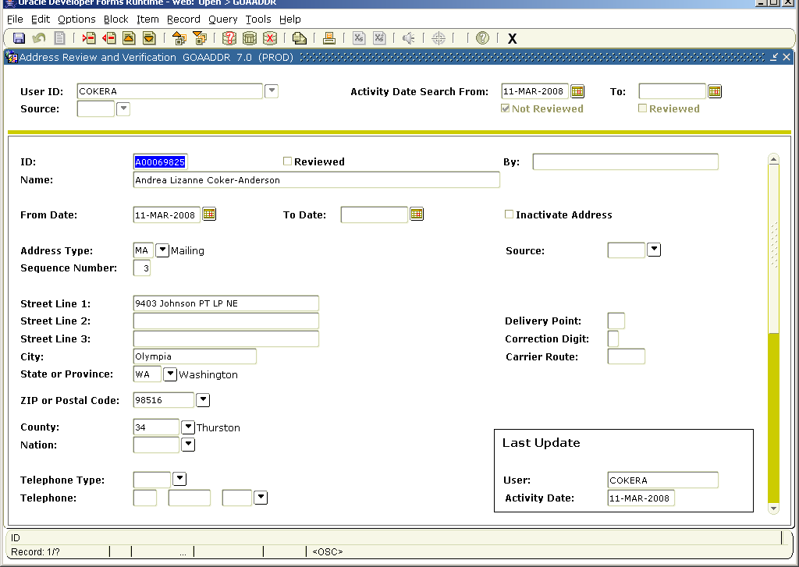

V. TELEPHONE NUMBERS

A. General Guidelines
A telephone number may be associated to an address using the same type (e.g. MA address and phone) on the telephone form. There must be an address with that type in the Address Information Block. The Comment field can be use to clarify the number, e.g. Spouse’s work number.

Delete old telephone number duplicates in the telephone form SPATELE.

B. Telephone Type—Required
Banner allows multiple phone numbers for a person or non-person. The Evergreen State College uses the following types:
BI | Billing
BU | Business/Work phone
CELL | Cell phone
EM | Emergency
FAX | Fax
MA | Day phone number, could be work number. Must be designated as primary number (Y) to be associated with MA address.
P2 | Parent 2 (parents with separate addresses)
PA | Parents
PAGE | Pager
PE | Applicant Preferred Email
PR | Permanent - Alternate phone number for permanent residence. Do not use if the same as the mailing address.
VN | Vendor
XC | Campus faculty/staff office
ZBU2 | 2nd Business-College Advancement
ZMA2 | 2nd Mailing-College Advancement
ZSEA | Seasonal Phone Number
ZREL | Relative-College Advancement
ZWTR | Winter Home-College Advancement

- Area Code—Compulsory. No Validation Table.
Must be entered for all phone numbers including area code 360.

Telephone—Compulsory for non-international numbers

Enter the three digit area code in the first box and then the seven-digit phone number without a hyphen in the second box. Extension numbers are entered in the 3rd box.

Telephone Primary Indicator—optional
Indicates a primary telephone number attached to an address type. It is set to active by the system when adding the telephone number in the address form. Check on or off on the form.
- Telephone Unlisted Indicator—optional
Indicates unlisted number. Check on or off in telephone form.
- Telephone Inactive Indicator
Use telephone Inactive box on the telephone form when a number is no longer valid.
- International Access - Code, Country and City are compulsory for international numbers
Enter the code, country and city codes with a space between each set of numbers.
- Comment - optional
Enter appropriate comments related to the telephone number.

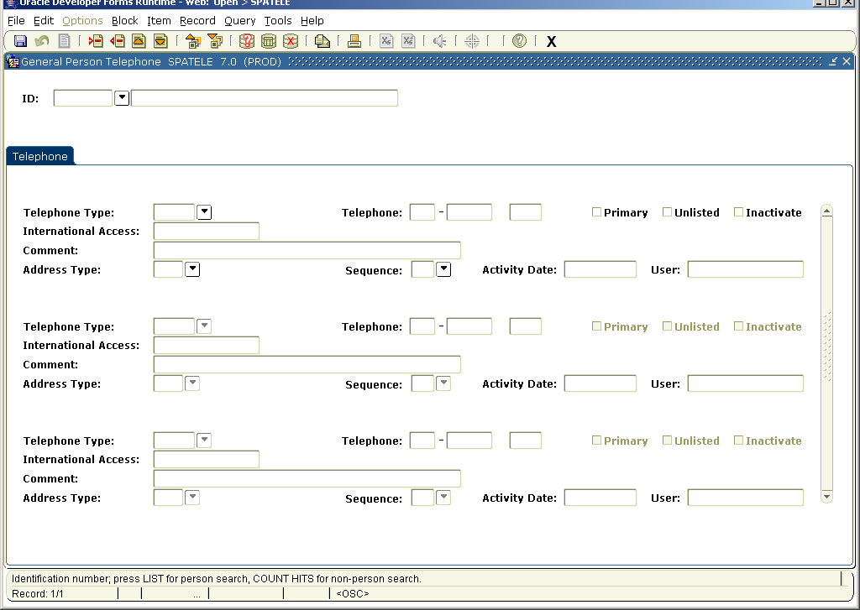

VI. E-MAIL ADDRESSES

Email types - GTVEMAL
ALT | Alternate
BI | Billing Email
FWD | Forwarded Email
PRE | Preferred
URL | Web Address/Uniform Resource Locator
WURL | Work Web Address/Uniform Resource Locator

In addition to these types, Banner allows one (1) email address to be marked as Preferred. Think of this one as the primary, preferred address for the individual.

Active students' email addresses are fed from the DUC database to Banner. If you modify a PRE type email address for an active student, this daily feed will overwrite your changes. FWD email addresses are also fed from DUC, for active students.

When modifying addresses for staff, faculty, non-active students or other entities, overwrite old address with new, rather than adding additional addresses. Inactivate addresses only when you have no viable replacement address for that type.

VII. NOTIFICATION OF DECEASED PROCEDURE

A person’s record will be flagged Deceased only upon receipt of one written document notification including any of the following:
Death Certificate
Newspaper death notice/Obituary article
Letter from a family member
Print out from Social Security Death Index
Telephone calls are not acceptable. Alumni or Registration & Records may request a written notification be sent to the office.
Refer all death notices to the Registration & Records Office.
The deceased flag is checked on the General Person form and the date of death entered in the date field.
The Deceased flag warning appears each time the record is accessed in the database.
Records converted from the Legacy system are flagged deceased with a default date, 31-DEC-1950.

VIII. DUPLICATE PIDM DELETION PROCESS

The deletion process consists of several procedures with multiple steps. Designated office staff identify and inactivate duplicate records to prevent further use. An Administrative Computing analyst selects a group of the identified PIDMS and prints a report of the PIDMs and their attached tables with data for staff to review. Staff can review and make corrections as needed. Below are the procedures and the steps each staff person follows:

A. Identification Procedure
1. Identify which record to keep. Research the reported duplicate PIDM to identify the good number. Use GUASYST to see where an I. D. has data. Additional Banner forms not showing on GUASYST are also researched. (e.g. SHACRSE)

2. Compare the data and entry dates in forms. Decide which ID number is the good one, based upon which modules have information. If the record does not contain data in your area, refer the record to appropriate office/s to review and make the decision.

3. For the “bad” PIDM, in the Identification Form (SPAIDEN, etc.):
In the last name field, enter USE ID and the number (Use ID A00012345).
In the first name field, enter a dash (-).
SAVE
Example: Last name: USE ID A00012345
First name: -
Middle name: delete and leave blank
NOTE: The deletion process is built on the Words USE ID in the last name field. Any other text will cause the record to not delete.

4. Contact the other office/s about moving information to the good ID. If the record has information in any of the following areas on GUASYST, email the name/s, good ID and bad ID to other affected offices to manage their information.
Student and Faculty Registration and Records Office
Admission and Recruit Admissions Office
Advancement Advancement Office
Financial Aid Financial Aid Office
Finance Business Services
Student Accounts Student Accounts Office
Faculty Academic Deans Office

5. Delete data or as much as possible or create null balance for Student Accounts. Delete the Alternate Information on the Identification Form, otherwise staff will keep pulling up the record.

B. Deletion Procedure

As of the update of this document on 3/11/08 it is unclear if we will continue to run a deletion process for Duplicate PIDMs based on the advice of Administrative Computing:

1. The Acceptance Report to delete PIDM (SZRACCP) is run by Administrative Computing to identify a group of records with “USE ID A….”.
Specific tables are selected by each office to appear on the report.
The report shows those tables that contain data.
The selected group of records is locked so no new records will be added before the deletion process.

2. Copies of the report are emailed to: Business Services, Student Accounts, Financial Aid, Admissions, Registration and Records, Academic Deans and Advancement.
Each area reviews the same version of the report.
Each reviewer should take no more than one week to review the report.
Each area reviews the report for their tables and data and determines if the information should be deleted, moved, or kept in the database on that PIDM. If the data should be kept intact, then the USE ID should be deleted from the name field and the correct name should be added.
The record will not be deleted if there is data in SORHOLD, SARADAP, SORTEST, SIBINST, SIRASGN, SHRTCKN, TBRACCD, AGBGIFT, AGBPLDG, or in any Finance Table. Financial Aid data will be deleted.
Finance data will not be deleted.

4. Admin. Computing is notified via email from each reviewer when their review is complete. The deletion process is run. WARNING: Once the data is deleted, it is gone!

5. Admin. Computing prints the Duplicate PIDM delete summary report (SZRDUPP). The report shows tables and data not deleted. A Delete failed message may indicate a temporary table with several records before a final record deleted message. Record deleted messages show on the report for each PIDM.

6. The report is emailed to the areas for review. Corrections/changes can be made to the records that weren’t deleted so they can be deleted next time the duplicate PIDM process is run.

